DOKUMENTACIJA

Web Programiranje 1

Milan Dobrosavljević

111/16

Contents

Uvod 2

Korišćeni programski jezici 2

Opis funkcionalnosti 2

Template 3

Organizacija 5

Organizaciona šema 5

5

Mapa sajta 5

Slike sajta i opis funkcionalnosti 8

Index 8

Shop 9

Men 10

Women 11

Shoes 12

Single 13

Contact 14

Autor 15

15

Kodovi 15

Index.js 15

Shop 26

Men 38

Women 46

Shoes 55

Single 62

Contact 71

Author 74

# Uvod

## Korišćeni programski jezici

Html,Css,Bootstrap,JavaScript,jQuery,Json

Korišćen je skinuti bootstrap template!

SEO optimizacija uradjena što se tiče meta description, keywords i alt tagova.

## Opis funkcionalnosti

Na svim stranama nalazi se dinamički učitana navigacija.

**Na index stranici nalazi se:**

Dinamički učitane kategorije, i svi proizvodi.

Filtrirani proizvodi na osnovu cene i broja zvezdica i prikaz najboljih

**Na shop stranici:**

Dinamički učitani svi proizvodi

Filter po ceni i boji proiuvoda

Sortiranje po ceni

**Na men stranici:**

Dinamički učitani svi muski proizvodi

Filter po ceni i boji proiuvoda

Sortiranje po ceni

**Na women stranici:**

Dinamički učitani svi zenski proizvodi

Filter po ceni i boji proiuvoda

Sortiranje po ceni

**Na shoes stranici:**

Dinamički učitane sve cipele proizvodi

Filter po ceni i boji proiuvoda

Sortiranje po ceni

**Na single stranici:**

Dinamički učitan proizvod na osnovu id-a iz urla

**Na contact strani:**

Regularni izrazi i prikaz greske ili potvrde

**Regularni izrazi**

U zavisnosti od korektnosti unosa ispisuju se greške ili potvrda o slanju emaila

## Template

Korišćen je skinuti template!

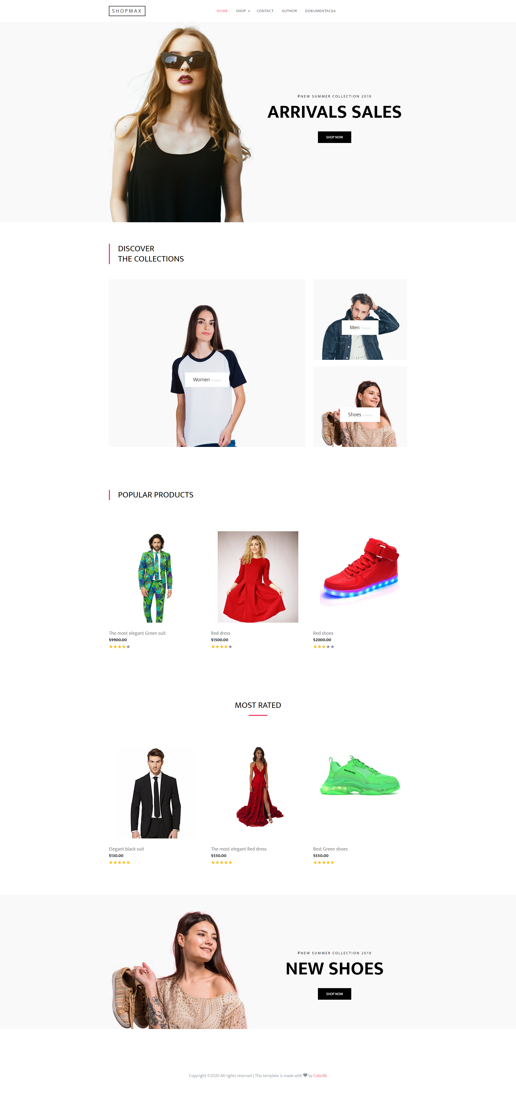

# Organizacija

## Organizaciona šema

## 

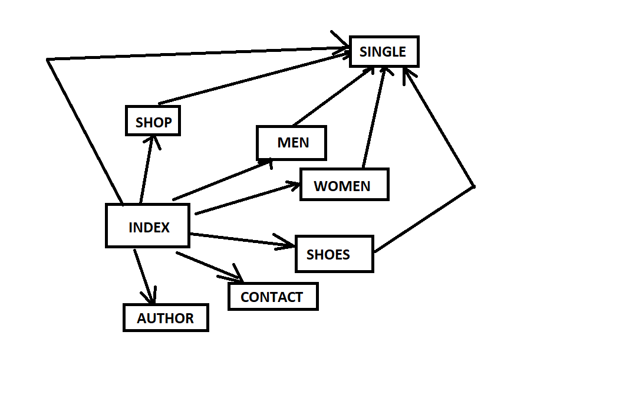

## Mapa sajta

<?xml version="1.0" encoding="UTF-8"?>

<urlset>

<url>

<loc>

shopmax/index.html

</loc>

<lastmod>2020-05-01T09:33:47+00:00</lastmod>

<changefreq>daily</changefreq>

<priority>1</priority>

</url>

<url>

<loc>

shopmax/shop.html

</loc>

<lastmod>2020-05-01T09:33:47+00:00</lastmod>

<changefreq>daily</changefreq>

<priority>1</priority>

</url>

<url>

<loc>

shopmax/men.html

</loc>

<lastmod>2020-05-01T09:33:47+00:00</lastmod>

<changefreq>daily</changefreq>

<priority>1</priority>

</url>

<url>

<loc>

shopmax/women.html

</loc>

<lastmod>2020-05-01T09:33:47+00:00</lastmod>

<changefreq>daily</changefreq>

<priority>1</priority>

</url>

<url>

<loc>

shopmax/shoes.html

</loc>

<lastmod>2020-05-01T09:33:47+00:00</lastmod>

<changefreq>daily</changefreq>

<priority>1</priority>

</url>

<url>

<loc>

shopmax/contact.html

</loc>

<lastmod>2020-05-01T09:33:47+00:00</lastmod>

<changefreq>monthly</changefreq>

<priority>0.7</priority>

</url>

<url>

<loc>

shopmax/about.html

</loc>

<lastmod>2020-05-01T09:33:47+00:00</lastmod>

<changefreq>yearly</changefreq>

<priority>0.5</priority>

</url>

</urlset>

## Slike sajta i opis funkcionalnosti

## Index



Opis funkcionalnosti:

Dinamički učitane kategorije, i svi proizvodi.

Filtrirani proizvodi na osnovu cene i broja zvezdica i prikaz najboljih

## Shop

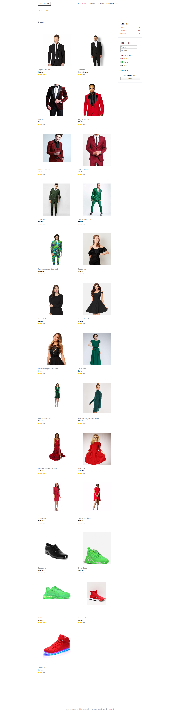

Opis funkcionalnosti:

Dinamički učitani svi proizvodi

Filter po ceni i boji proiuvoda

Sortiranje po ceni

## Men

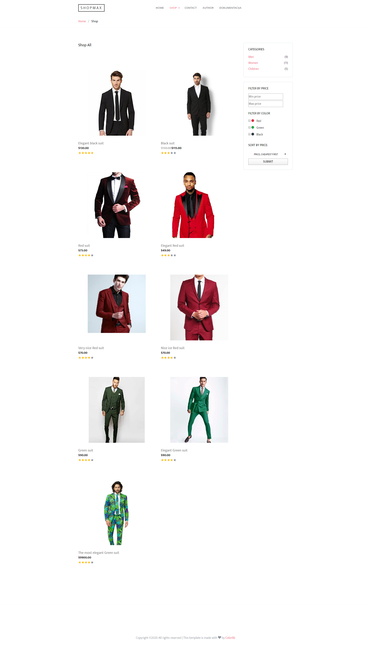

Opis funkcionalnosti:

Dinamički učitani svi muski proizvodi

Filter po ceni i boji proiuvoda

Sortiranje po ceni

## Women

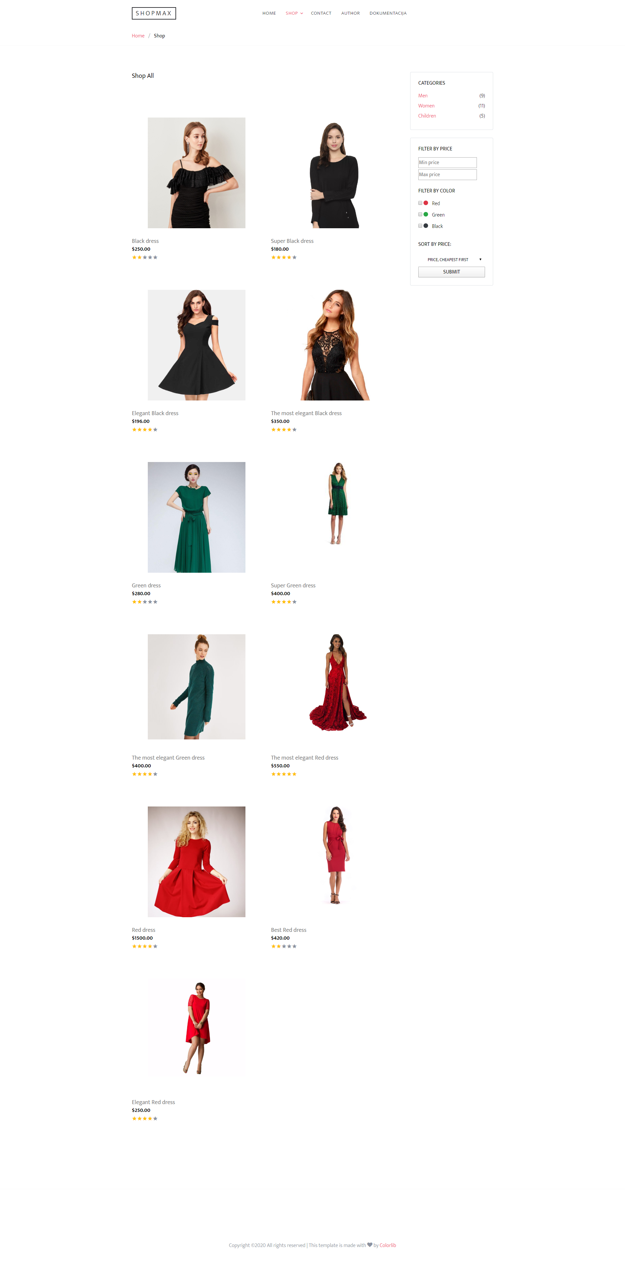

Opis funkcionalnosti:

Dinamički učitani svi zenski proizvodi

Filter po ceni i boji proiuvoda

Sortiranje po ceni

## Shoes

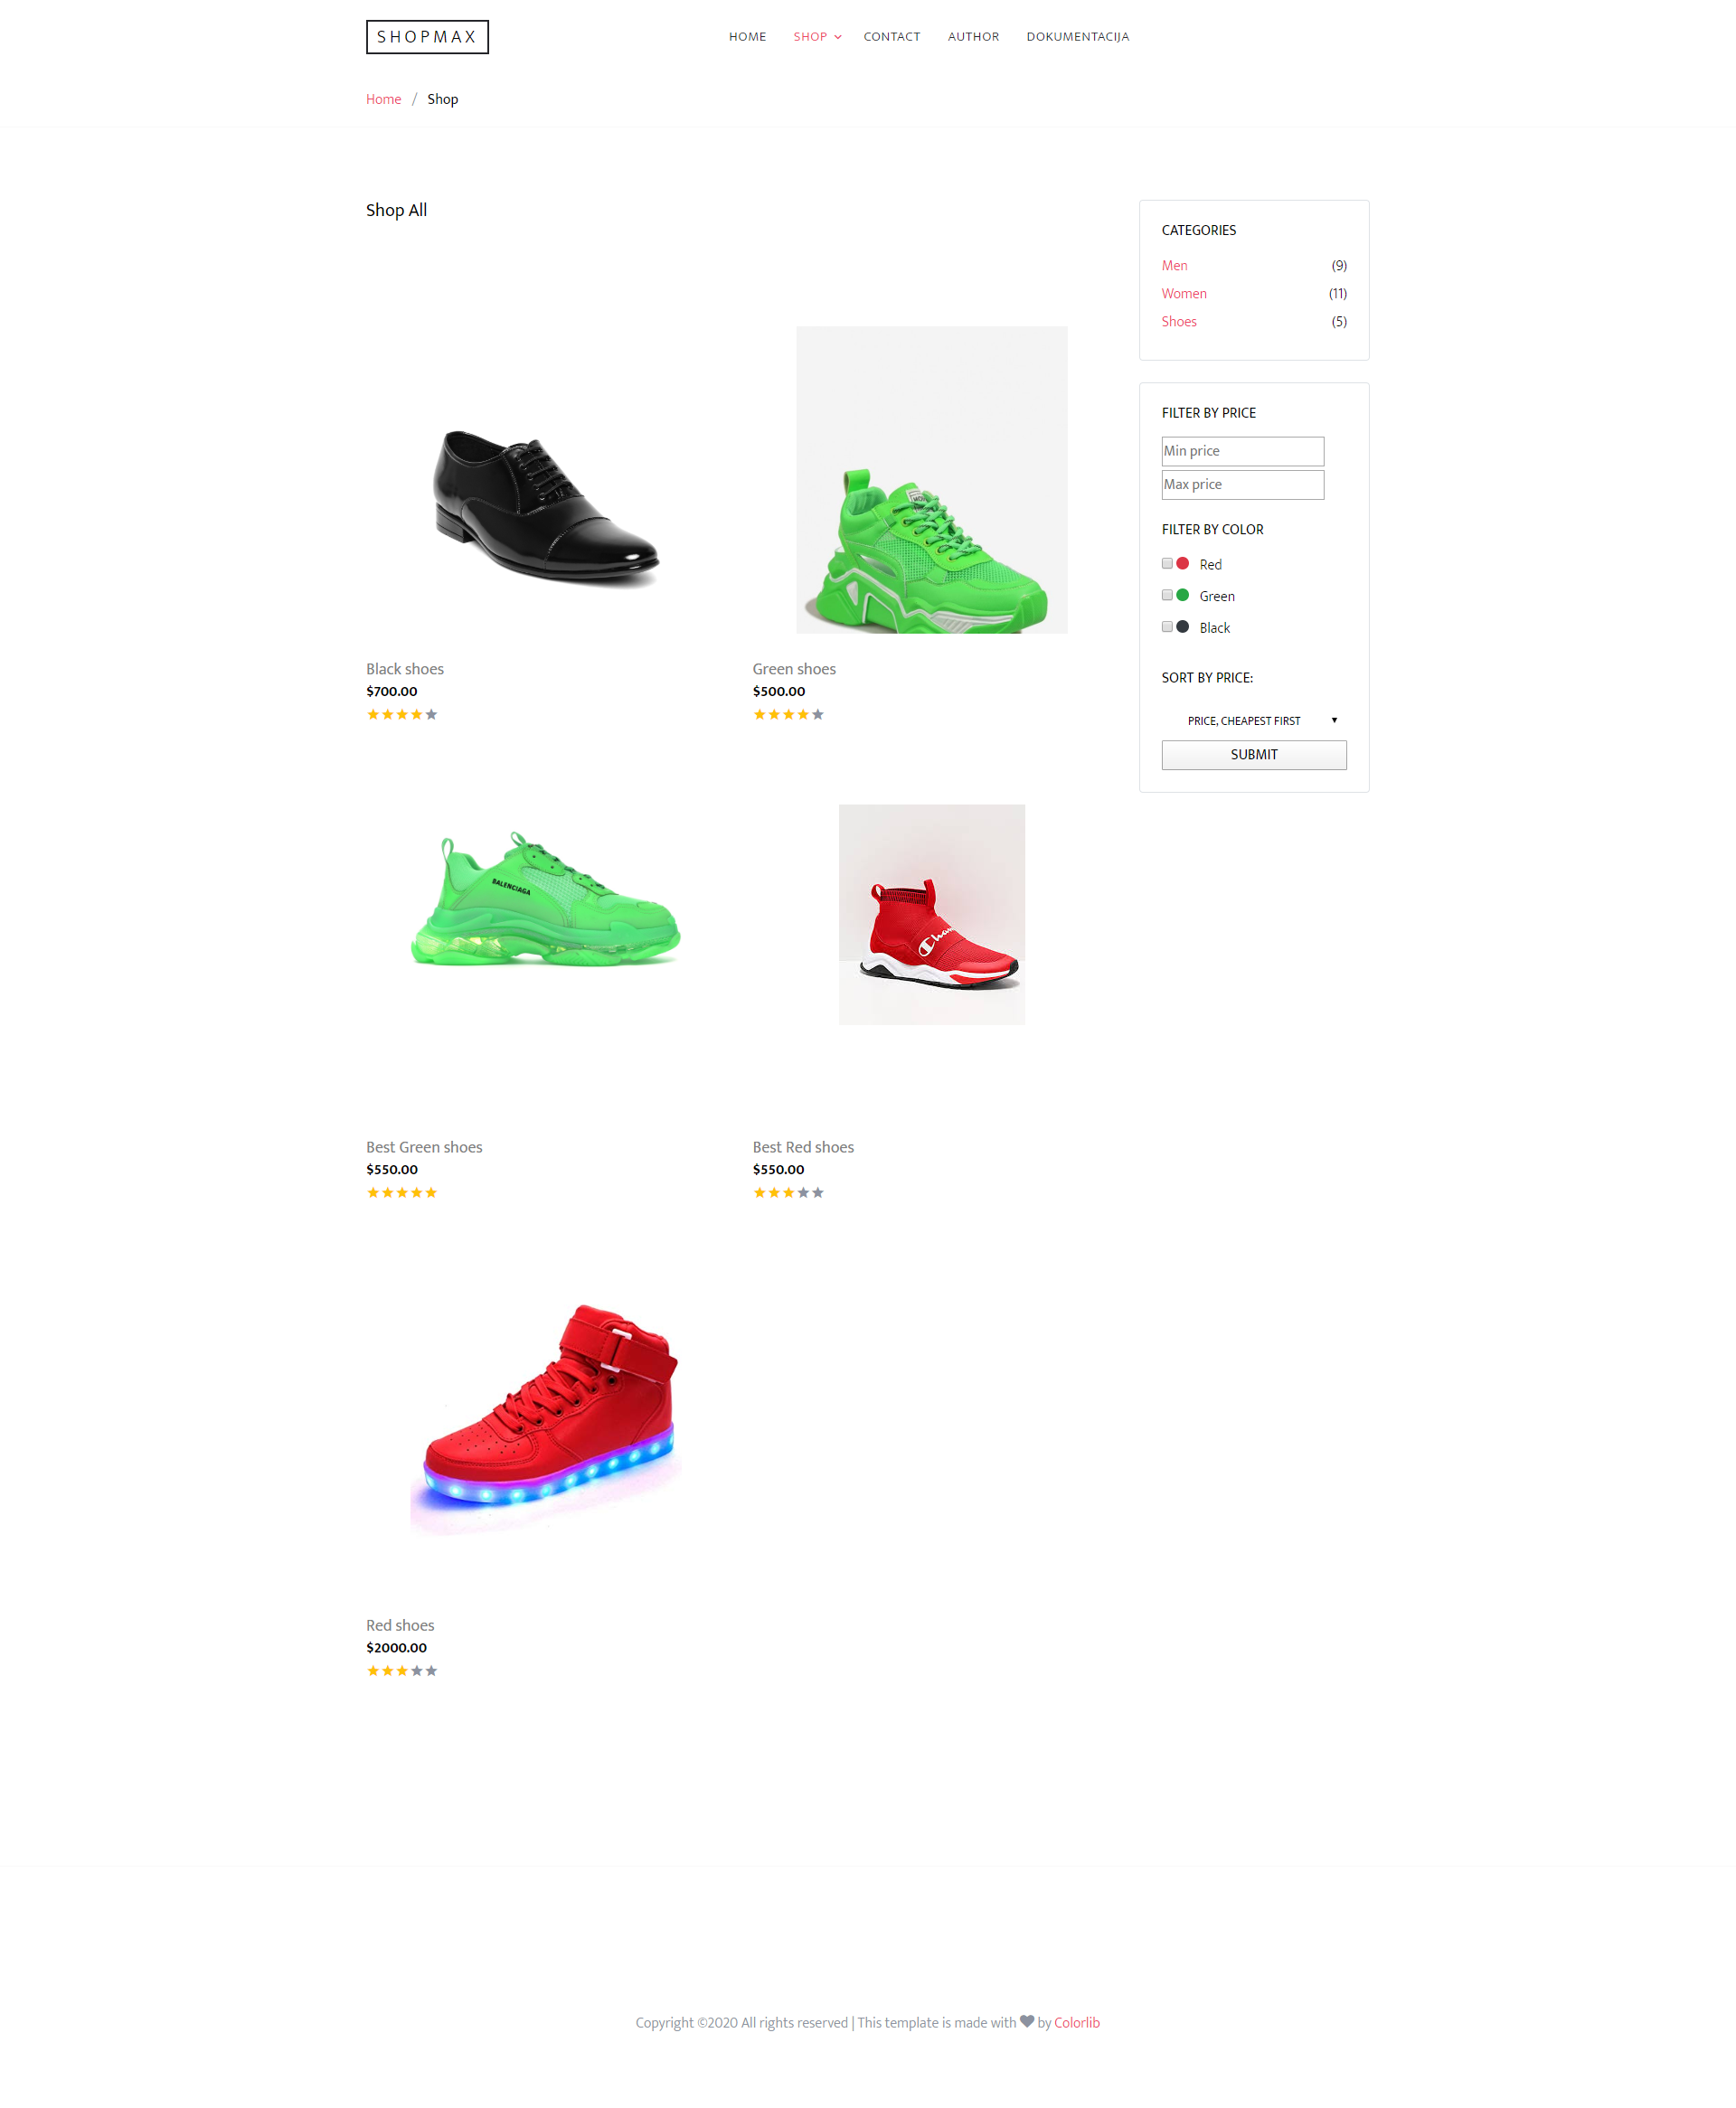

Opis funkcionalnosti:

Dinamički učitani svi zenski proizvodi

Filter po ceni i boji proiuvoda

Sortiranje po ceni

## Single

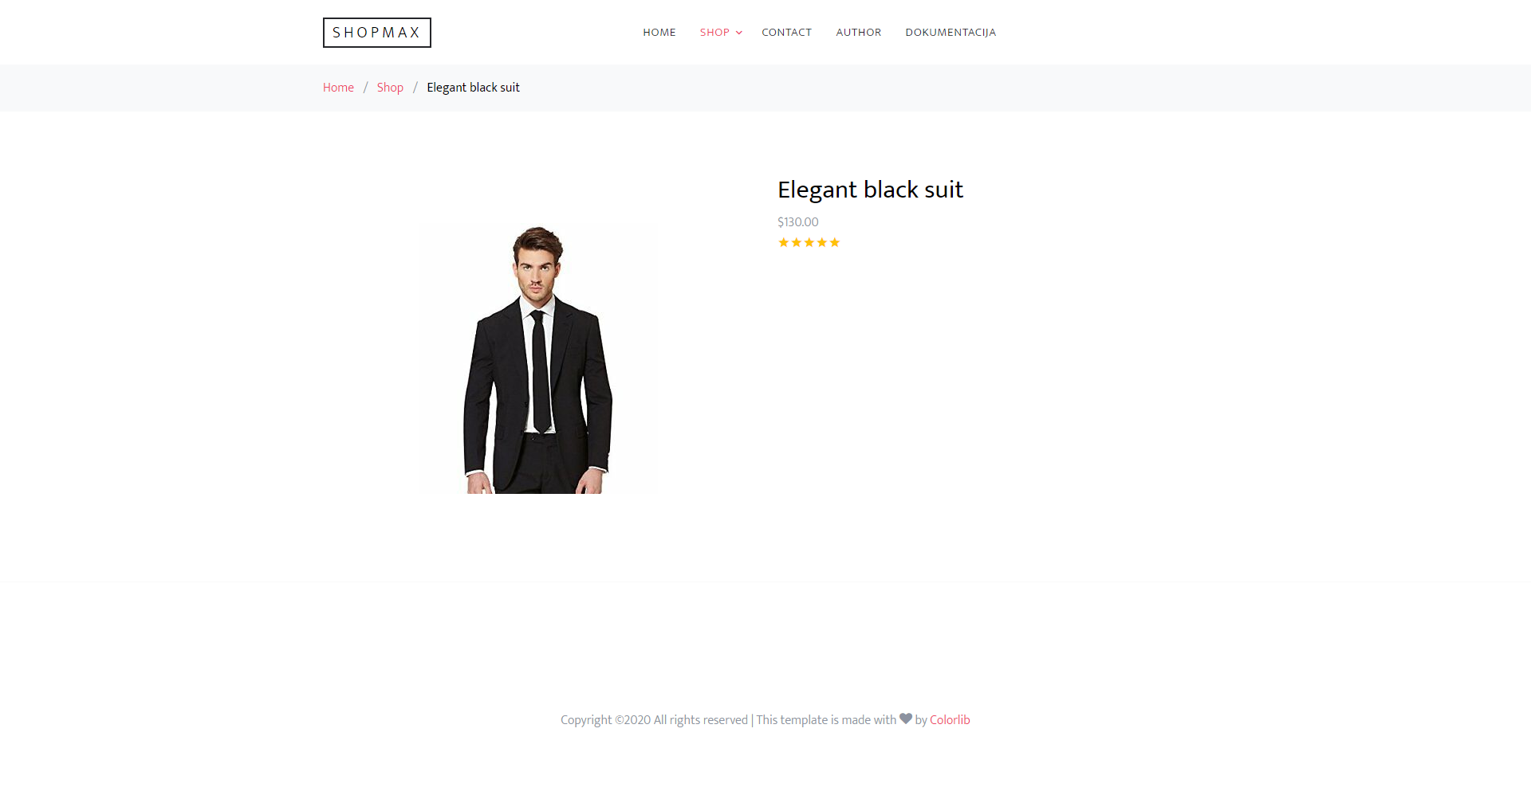

Opis funkcionalnosti:

Dinamičko ispisivanje proizvoda na osnovu id-a iz urla

## Contact

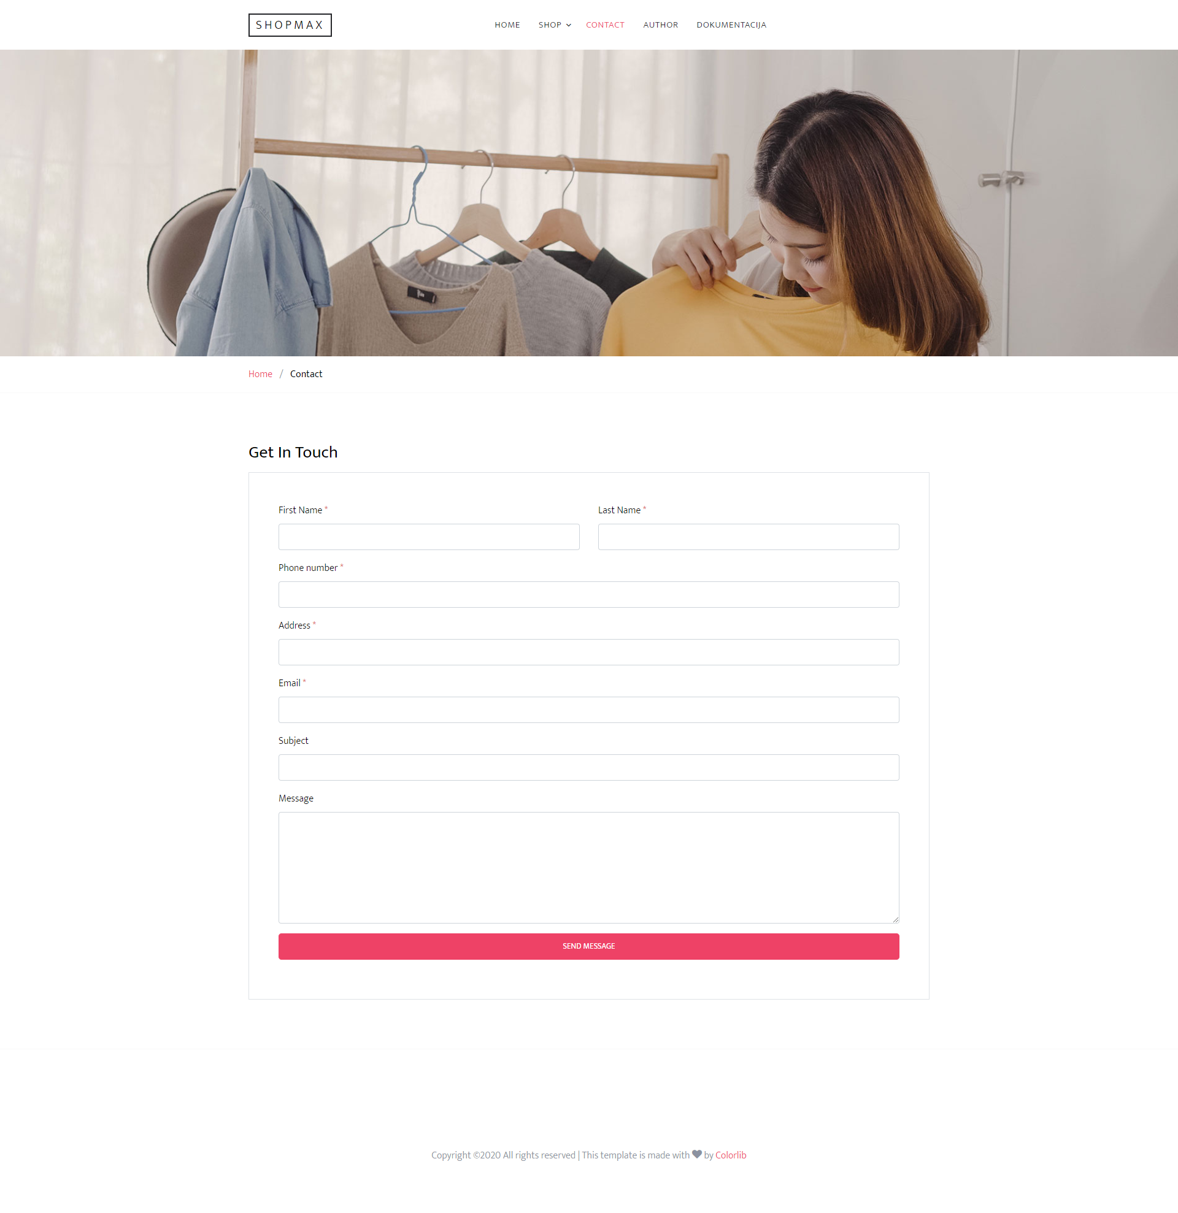

Opis funkcionalnosti:

Regularni izrazi i prikaz greske ili potvrde

## Autor

# 

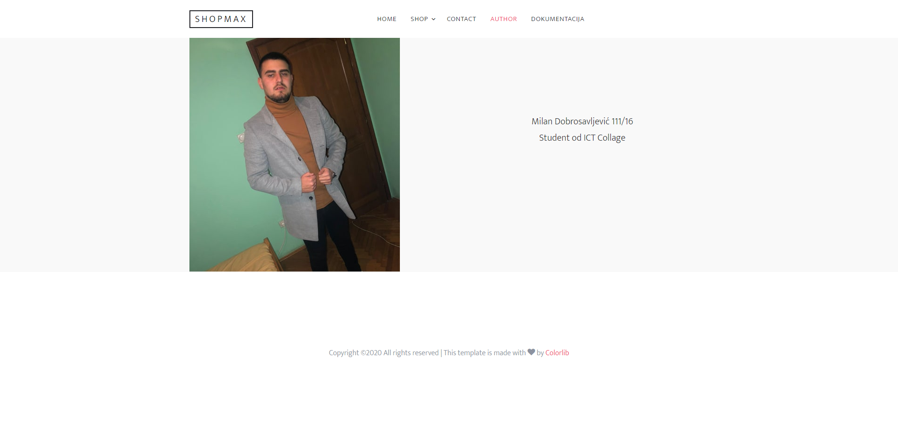

# Kodovi

## Index.js

$(document).ready(function(){

*//ITEMS*

*//ITEMS*

    var items=[

        {

            "id":1,

            "slika":{

                "src":"men/black.jpg",

                "alt":"black suit"

            },

            "naziv":"Elegant black suit",

            "kategorija":"men",

            "cena":130,

            "zvezdice":5,

            "boja":"crna"

        },

        {

            "id":2,

            "slika":{

                "src":"men/black1.jpg",

                "alt":"black suit"

            },

            "naziv":"Black suit",

            "kategorija":"men",

            "cena":115,

            "staraCena":150,

            "zvezdice":3,

            "boja":"crna"

        },

        {

            "id":3,

            "slika":{

                "src":"men/red.jpg",

                "alt":"red suit"

            },

            "naziv":"Red suit",

            "kategorija":"men",

            "cena":75,

            "zvezdice":4,

            "boja":"crvena"

        },

        {

            "id":4,

            "slika":{

                "src":"men/red1.jpg",

                "alt":"red suit"

            },

            "naziv":"Elegant Red suit",

            "kategorija":"men",

            "cena":49,

            "zvezdice":3,

            "boja":"crvena"

        },

        {

            "id":5,

            "slika":{

                "src":"men/red2.jpg",

                "alt":"red suit"

            },

            "naziv":"Very nice Red suit",

            "kategorija":"men",

            "cena":70,

            "zvezdice":4,

            "boja":"crvena"

        },

        {

            "id":6,

            "slika":{

                "src":"men/red3.jpg",

                "alt":"red suit"

            },

            "naziv":"Nice ice Red suit",

            "kategorija":"men",

            "cena":70,

            "zvezdice":4,

            "boja":"crvena"

        },

        {

            "id":7,

            "slika":{

                "src":"men/green.jpg",

                "alt":"green suit"

            },

            "naziv":"Green suit",

            "kategorija":"men",

            "cena":90,

            "zvezdice":4,

            "boja":"zelena"

        },

        {

            "id":8,

            "slika":{

                "src":"men/green1.jpg",

                "alt":"green suit"

            },

            "naziv":"Elegant Green suit",

            "kategorija":"men",

            "cena":90,

            "zvezdice":4,

            "boja":"zelena"

        },

        {

            "id":9,

            "slika":{

                "src":"men/green2.jpg",

                "alt":"green suit"

            },

            "naziv":"The most elegant Green suit",

            "kategorija":"men",

            "cena":9900,

            "zvezdice":4,

            "boja":"zelena"

        },

        {

            "id":10,

            "slika":{

                "src":"women/black.jpg",

                "alt":"black suit"

            },

            "naziv":"Black dress",

            "kategorija":"women",

            "cena":250,

            "zvezdice":2,

            "boja":"crna"

        },

        {

            "id":11,

            "slika":{

                "src":"women/black1.jpg",

                "alt":"black suit"

            },

            "naziv":"Super Black dress",

            "kategorija":"women",

            "cena":180,

            "zvezdice":4,

            "boja":"crna"

        },

        {

            "id":12,

            "slika":{

                "src":"women/black2.jpeg",

                "alt":"black suit"

            },

            "naziv":"Elegant Black dress",

            "kategorija":"women",

            "cena":196,

            "zvezdice":4,

            "boja":"crna"

        },

        {

            "id":13,

            "slika":{

                "src":"women/black3.jpg",

                "alt":"black suit"

            },

            "naziv":"The most elegant Black dress",

            "kategorija":"women",

            "cena":350,

            "zvezdice":4,

            "boja":"crna"

        },

        {

            "id":14,

            "slika":{

                "src":"women/green.jpg",

                "alt":"green suit"

            },

            "naziv":"Green dress",

            "kategorija":"women",

            "cena":280,

            "zvezdice":2,

            "boja":"zelena"

        },

        {

            "id":15,

            "slika":{

                "src":"women/green1.jpg",

                "alt":"green suit"

            },

            "naziv":"Super Green dress",

            "kategorija":"women",

            "cena":400,

            "zvezdice":4,

            "boja":"zelena"

        },

        {

            "id":16,

            "slika":{

                "src":"women/green2.jpg",

                "alt":"green suit"

            },

            "naziv":"The most elegant Green dress",

            "kategorija":"women",

            "cena":400,

            "zvezdice":4,

            "boja":"zelena"

        },

        {

            "id":17,

            "slika":{

                "src":"women/red.jpg",

                "alt":"red suit"

            },

            "naziv":"The most elegant Red dress",

            "kategorija":"women",

            "cena":550,

            "zvezdice":5,

            "boja":"crvena"

        },

        {

            "id":18,

            "slika":{

                "src":"women/red1.jpg",

                "alt":"red suit"

            },

            "naziv":"Red dress",

            "kategorija":"women",

            "cena":1500,

            "zvezdice":4,

            "boja":"crvena"

        },

        {

            "id":19,

            "slika":{

                "src":"women/red2.jpg",

                "alt":"red suit"

            },

            "naziv":"Best Red dress",

            "kategorija":"women",

            "cena":420,

            "zvezdice":2,

            "boja":"crvena"

        },

        {

            "id":20,

            "slika":{

                "src":"women/red3.jpg",

                "alt":"red suit"

            },

            "naziv":"Elegant Red dress",

            "kategorija":"women",

            "cena":250,

            "zvezdice":4,

            "boja":"crvena"

        },

        {

            "id":21,

            "slika":{

                "src":"shoes/black.jpg",

                "alt":"black shoes"

            },

            "naziv":"Black shoes",

            "kategorija":"shoes",

            "cena":700,

            "zvezdice":4,

            "boja":"crna"

        },

        {

            "id":22,

            "slika":{

                "src":"shoes/green.jpg",

                "alt":"green shoes"

            },

            "naziv":"Green shoes",

            "kategorija":"shoes",

            "cena":500,

            "zvezdice":4,

            "boja":"zelena"

        },

        {

            "id":23,

            "slika":{

                "src":"shoes/green1.jpg",

                "alt":"green shoes"

            },

            "naziv":"Best Green shoes",

            "kategorija":"shoes",

            "cena":550,

            "zvezdice":5,

            "boja":"zelena"

        },

        {

            "id":24,

            "slika":{

                "src":"shoes/red1.jpg",

                "alt":"red shoes"

            },

            "naziv":"Best Red shoes",

            "kategorija":"shoes",

            "cena":550,

            "zvezdice":3,

            "boja":"crvena"

        },

        {

            "id":25,

            "slika":{

                "src":"shoes/red2.jpg",

                "alt":"red shoes"

            },

            "naziv":"Red shoes",

            "kategorija":"shoes",

            "cena":2000,

            "zvezdice":3,

            "boja":"crvena"

        },

    ]

*//DINAMICKO ISPISIVANJE MENIJA*

    var menu=[

        {

            "link":"index.html",

            "tekst":"Home",

            "class":"active"

        },

        {

            "link":"shop.html",

            "tekst":"Shop",

            "class":"menu-has-children",

            "children":[

                {

                    "link":"men.html",

                    "tekst":"Men Collection",

                },

                {

                    "link":"women.html",

                    "tekst":"Women Collestion",

                },

                {

                    "link":"shoes.html",

                    "tekst":"Shoes",

                }

            ]

        },

        {

            "link":"contact.html",

            "tekst":"Contact"

        },

        {

            "link":"about.html",

            "tekst":"Author"

        },

        {

            "link":"DOKUMENTACIJA.pdf",

            "tekst":"DOKUMENTACIJA"

        },

    ]

*//DINAMICKO ISPISIVANJE KOLEKCIJA*

    var kolekcije=[

        {

            "link":"women.html",

            "slika":{

                "src":"images/model_4.png",

                "alt":"Women"

            },

            "naziv":"Women",

            "items":9,

        },

        {

            "link":"men.html",

            "slika":{

                "src":"images/model_5.png",

                "alt":"Men"

            },

            "naziv":"Men",

            "items":9,

        },

        {

            "link":"shoes.html",

            "slika":{

                "src":"images/model_6.png",

                "alt":"shoes"

            },

            "naziv":"Shoes",

            "items":9,

        }

    ]

    IspisiMeni(menu);

    ispisiKolekcije(kolekcije);

    popularni(items);

    ispisiNajboljeOcenjene(items);

})

function IspisiMeni(podatak){

    var ispis="";

*for*(var i=0;i<podatak.length;i++){

*if*(podatak[i].hasOwnProperty('children')){

            ispis+='<li class="has-children"><a href="'+podatak[i]['link']+'">'+podatak[i]['tekst']+'</a>'+

            '<ul class="dropdown">';

*for*(var j=0;j<podatak[i]['children'].length;j++){

                    ispis+='<li><a href="'+podatak[i]['children'][j]['link']+'">'+podatak[i]['children'][j]['tekst']+'</a>';

                };

            ispis+='</ul>'+

          '</li>';

        }*else* *if*(podatak[i].hasOwnProperty('class')){

            ispis+='<li class="'+podatak[i]['class']+'"><a href="'+podatak[i]['link']+'">'+podatak[i]['tekst']+'</a></li>';

        }*else*{

            ispis+='<li><a href="'+podatak[i]['link']+'">'+podatak[i]['tekst']+'</a></li>';

        }

    }

    $(".site-menu").html(ispis);

}

function ispisiKolekcije(podatak){

    var ispis="";

*for*(var i=0;i<podatak.length;i++){

*if*(i==0){

            ispis+='<div class="col-lg-8">'+

            '<div class="product-item sm-height full-height bg-gray">'+

              '<a href="'+podatak[i]['link']+'" class="product-category">'+podatak[i]['naziv']+' <span>'+podatak[i]['items']+' items</span></a>'+

              '<img src="'+podatak[i]['slika']['src']+'" alt="'+podatak[i]['slika']['alt']+'" class="img-fluid">'+

            '</div></div>';

        }

*else* *if*(i==1){

            ispis+='<div class="col-lg-4">'+

            '<div class="product-item sm-height bg-gray mb-4">'+

              '<a href="'+podatak[i]['link']+'" class="product-category">'+podatak[i]['naziv']+' <span>'+podatak[i]['items']+' items</span></a>'+

              '<img src="'+podatak[i]['slika']['src']+'" alt="'+podatak[i]['slika']['alt']+'" class="img-fluid">'+

            '</div>';

        }

*else*{

            ispis+='<div class="product-item sm-height bg-gray">'+

              '<a href="'+podatak[i]['link']+'" class="product-category">'+podatak[i]['naziv']+' <span>'+podatak[i]['items']+' items</span></a>'+

              '<img src="'+podatak[i]['slika']['src']+'" alt="'+podatak[i]['slika']['alt']+'" class="img-fluid">'+

            '</div></div>';

        }

    }

    $(".kolekcije").html(ispis);

}

function popularni(podatak){

    ispis="";

*for*(var i=0;i<podatak.length;i++){

*if*(podatak[i]['cena']>1000){

            ispis+='<div class="col-lg-4 col-md-6 item-entry mb-4">'+

            '<a href="single.html?id='+podatak[i]["id"]+'" class="product-item md-height d-block">'+

              '<img src="images/'+podatak[i]["slika"]["src"]+'" alt="'+podatak[i]['slika']['alt']+'" class="img-fluid">'+

            '</a>'+

            '<h2 class="item-title"><a href="#">'+podatak[i]['naziv']+'</a></h2>'+

            '<strong class="item-price">';

*if*(podatak[i].hasOwnProperty("staraCena")){

                ispis+='<del>$'+podatak[i]['staraCena']+'.00</del>';

            }

            ispis+='$'+podatak[i]['cena']+'.00</strong>'+

            '<div class="star-rating">';

*for*(var y=0; y<podatak[i]['zvezdice'];y++){

                ispis+='<span class="icon-star2 text-warning"></span>';

            }

*for*(var y=podatak[i]['zvezdice'];y<5;y++){

                 ispis+='<span class="icon-star2"></span>';

            }

            ispis+='</div>'+

          '</div>';

        }

    }

    $(".popularni").html(ispis);

}

function ispisiNajboljeOcenjene(podatak){

    ispis="";

*for*(var i=0;i<podatak.length;i++){

*if*(podatak[i]['zvezdice']==5){

            ispis+='<div class="col-lg-4 col-md-6 item-entry mb-4">'+

            '<a href="single.html?id='+podatak[i]["id"]+'" class="product-item md-height d-block">'+

              '<img src="images/'+podatak[i]["slika"]["src"]+'" alt="'+podatak[i]['slika']['alt']+'" class="img-fluid">'+

            '</a>'+

            '<h2 class="item-title"><a href="#">'+podatak[i]['naziv']+'</a></h2>'+

            '<strong class="item-price">';

*if*(podatak[i].hasOwnProperty("staraCena")){

                ispis+='<del>$'+podatak[i]['staraCena']+'.00</del>';

            }

            ispis+='$'+podatak[i]['cena']+'.00</strong>'+

            '<div class="star-rating">';

*for*(var y=0; y<podatak[i]['zvezdice'];y++){

                ispis+='<span class="icon-star2 text-warning"></span>';

            }

            ispis+='</div>'+

          '</div>';

        }

    }

    $(".najboljeOcenjeni").html(ispis);

}

## Shop

$(document).ready(function(){

*//ITEMS*

    var items=[

        {

            "id":1,

            "slika":{

                "src":"men/black.jpg",

                "alt":"black suit"

            },

            "naziv":"Elegant black suit",

            "kategorija":"men",

            "cena":130,

            "zvezdice":5,

            "boja":"crna"

        },

        {

            "id":2,

            "slika":{

                "src":"men/black1.jpg",

                "alt":"black suit"

            },

            "naziv":"Black suit",

            "kategorija":"men",

            "cena":115,

            "staraCena":150,

            "zvezdice":3,

            "boja":"crna"

        },

        {

            "id":3,

            "slika":{

                "src":"men/red.jpg",

                "alt":"red suit"

            },

            "naziv":"Red suit",

            "kategorija":"men",

            "cena":75,

            "zvezdice":4,

            "boja":"crvena"

        },

        {

            "id":4,

            "slika":{

                "src":"men/red1.jpg",

                "alt":"red suit"

            },

            "naziv":"Elegant Red suit",

            "kategorija":"men",

            "cena":49,

            "zvezdice":3,

            "boja":"crvena"

        },

        {

            "id":5,

            "slika":{

                "src":"men/red2.jpg",

                "alt":"red suit"

            },

            "naziv":"Very nice Red suit",

            "kategorija":"men",

            "cena":70,

            "zvezdice":4,

            "boja":"crvena"

        },

        {

            "id":6,

            "slika":{

                "src":"men/red3.jpg",

                "alt":"red suit"

            },

            "naziv":"Nice ice Red suit",

            "kategorija":"men",

            "cena":70,

            "zvezdice":4,

            "boja":"crvena"

        },

        {

            "id":7,

            "slika":{

                "src":"men/green.jpg",

                "alt":"green suit"

            },

            "naziv":"Green suit",

            "kategorija":"men",

            "cena":90,

            "zvezdice":4,

            "boja":"zelena"

        },

        {

            "id":8,

            "slika":{

                "src":"men/green1.jpg",

                "alt":"green suit"

            },

            "naziv":"Elegant Green suit",

            "kategorija":"men",

            "cena":90,

            "zvezdice":4,

            "boja":"zelena"

        },

        {

            "id":9,

            "slika":{

                "src":"men/green2.jpg",

                "alt":"green suit"

            },

            "naziv":"The most elegant Green suit",

            "kategorija":"men",

            "cena":9900,

            "zvezdice":4,

            "boja":"zelena"

        },

        {

            "id":10,

            "slika":{

                "src":"women/black.jpg",

                "alt":"black suit"

            },

            "naziv":"Black dress",

            "kategorija":"women",

            "cena":250,

            "zvezdice":2,

            "boja":"crna"

        },

        {

            "id":11,

            "slika":{

                "src":"women/black1.jpg",

                "alt":"black suit"

            },

            "naziv":"Super Black dress",

            "kategorija":"women",

            "cena":180,

            "zvezdice":4,

            "boja":"crna"

        },

        {

            "id":12,

            "slika":{

                "src":"women/black2.jpeg",

                "alt":"black suit"

            },

            "naziv":"Elegant Black dress",

            "kategorija":"women",

            "cena":196,

            "zvezdice":4,

            "boja":"crna"

        },

        {

            "id":13,

            "slika":{

                "src":"women/black3.jpg",

                "alt":"black suit"

            },

            "naziv":"The most elegant Black dress",

            "kategorija":"women",

            "cena":350,

            "zvezdice":4,

            "boja":"crna"

        },

        {

            "id":14,

            "slika":{

                "src":"women/green.jpg",

                "alt":"green suit"

            },

            "naziv":"Green dress",

            "kategorija":"women",

            "cena":280,

            "zvezdice":2,

            "boja":"zelena"

        },

        {

            "id":15,

            "slika":{

                "src":"women/green1.jpg",

                "alt":"green suit"

            },

            "naziv":"Super Green dress",

            "kategorija":"women",

            "cena":400,

            "zvezdice":4,

            "boja":"zelena"

        },

        {

            "id":16,

            "slika":{

                "src":"women/green2.jpg",

                "alt":"green suit"

            },

            "naziv":"The most elegant Green dress",

            "kategorija":"women",

            "cena":400,

            "zvezdice":4,

            "boja":"zelena"

        },

        {

            "id":17,

            "slika":{

                "src":"women/red.jpg",

                "alt":"red suit"

            },

            "naziv":"The most elegant Red dress",

            "kategorija":"women",

            "cena":550,

            "zvezdice":5,

            "boja":"crvena"

        },

        {

            "id":18,

            "slika":{

                "src":"women/red1.jpg",

                "alt":"red suit"

            },

            "naziv":"Red dress",

            "kategorija":"women",

            "cena":1500,

            "zvezdice":4,

            "boja":"crvena"

        },

        {

            "id":19,

            "slika":{

                "src":"women/red2.jpg",

                "alt":"red suit"

            },

            "naziv":"Best Red dress",

            "kategorija":"women",

            "cena":420,

            "zvezdice":2,

            "boja":"crvena"

        },

        {

            "id":20,

            "slika":{

                "src":"women/red3.jpg",

                "alt":"red suit"

            },

            "naziv":"Elegant Red dress",

            "kategorija":"women",

            "cena":250,

            "zvezdice":4,

            "boja":"crvena"

        },

        {

            "id":21,

            "slika":{

                "src":"shoes/black.jpg",

                "alt":"black shoes"

            },

            "naziv":"Black shoes",

            "kategorija":"shoes",

            "cena":700,

            "zvezdice":4,

            "boja":"crna"

        },

        {

            "id":22,

            "slika":{

                "src":"shoes/green.jpg",

                "alt":"green shoes"

            },

            "naziv":"Green shoes",

            "kategorija":"shoes",

            "cena":500,

            "zvezdice":4,

            "boja":"zelena"

        },

        {

            "id":23,

            "slika":{

                "src":"shoes/green1.jpg",

                "alt":"green shoes"

            },

            "naziv":"Best Green shoes",

            "kategorija":"shoes",

            "cena":550,

            "zvezdice":5,

            "boja":"zelena"

        },

        {

            "id":24,

            "slika":{

                "src":"shoes/red1.jpg",

                "alt":"red shoes"

            },

            "naziv":"Best Red shoes",

            "kategorija":"shoes",

            "cena":550,

            "zvezdice":3,

            "boja":"crvena"

        },

        {

            "id":25,

            "slika":{

                "src":"shoes/red2.jpg",

                "alt":"red shoes"

            },

            "naziv":"Red shoes",

            "kategorija":"shoes",

            "cena":2000,

            "zvezdice":3,

            "boja":"crvena"

        },

    ]

*//DINAMICKO ISPISIVANJE MENIJA*

    var menu=[

        {

            "link":"index.html",

            "tekst":"Home",

        },

        {

            "link":"shop.html",

            "tekst":"Shop",

            "class":"menu-has-children active",

            "children":[

                {

                    "link":"men.html",

                    "tekst":"Men Collection",

                },

                {

                    "link":"women.html",

                    "tekst":"Women Collestion",

                },

                {

                    "link":"shoes.html",

                    "tekst":"Shoes",

                }

            ]

        },

        {

            "link":"contact.html",

            "tekst":"Contact"

        },

        {

            "link":"about.html",

            "tekst":"Author"

        },

        {

            "link":"DOKUMENTACIJA.pdf",

            "tekst":"DOKUMENTACIJA"

        },

    ]

    IspisiMeni(menu);

    itemIspis(items);

    $("#potvrdiFilter").click(function(){

        filter(items);

    });

})

function IspisiMeni(podatak){

    var ispis="";

*for*(var i=0;i<podatak.length;i++){

*if*(podatak[i].hasOwnProperty('children')){

            ispis+='<li class="has-children active"><a href="'+podatak[i]['link']+'">'+podatak[i]['tekst']+'</a>'+

            '<ul class="dropdown">';

*for*(var j=0;j<podatak[i]['children'].length;j++){

                    ispis+='<li><a href="'+podatak[i]['children'][j]['link']+'">'+podatak[i]['children'][j]['tekst']+'</a>';

                };

            ispis+='</ul>'+

          '</li>';

        }*else* *if*(podatak[i].hasOwnProperty('class')){

            ispis+='<li class="'+podatak[i]['class']+'"><a href="'+podatak[i]['link']+'">'+podatak[i]['tekst']+'</a></li>';

        }*else*{

            ispis+='<li><a href="'+podatak[i]['link']+'">'+podatak[i]['tekst']+'</a></li>';

        }

    }

    $(".site-menu").html(ispis);

}

function itemIspis(podatak){

    ispis="";

*for*(var i=0;i<podatak.length;i++){

            ispis+='<div class="col-lg-6 col-md-6 item-entry mb-4">'+

            '<a href="single.html?id='+podatak[i]["id"]+'" class="product-item md-height d-block">'+

              '<img src="images/'+podatak[i]["slika"]["src"]+'" alt="'+podatak[i]['slika']['alt']+'" class="img-fluid">'+

            '</a>'+

            '<h2 class="item-title"><a href="#">'+podatak[i]['naziv']+'</a></h2>'+

            '<strong class="item-price">';

*if*(podatak[i].hasOwnProperty("staraCena")){

                ispis+='<del>$'+podatak[i]['staraCena']+'.00</del>';

            }

            ispis+='$'+podatak[i]['cena']+'.00</strong>'+

            '<div class="star-rating">';

*for*(var y=0; y<podatak[i]['zvezdice'];y++){

                ispis+='<span class="icon-star2 text-warning"></span>';

            }

*for*(var y=podatak[i]['zvezdice'];y<5;y++){

                 ispis+='<span class="icon-star2"></span>';

            }

            ispis+='</div>'+

          '</div>';

    }

    $(".proizvodi").html(ispis);

}

*//FILTRIRANJE*

    function filter(data){

        var x = document.getElementById("cenaOd").value;

        var y = document.getElementById("cenaDo").value;

        var a = document.getElementById("sortiranje");

        var b = document.getElementById("sortiranje").selectedIndex;

        var c = a.options[b].value;

        var crvena = document.querySelector('#color1').checked;

        var zelena = document.querySelector('#color2').checked;

        var crna = document.querySelector('#color3').checked;

*if*(c==0 && x==0 && y==0)ispisi(data);

*if*(crvena || zelena || crna ) boje(data);

*else* *if*(c!=0)sortiranje(data);

*else* *if*(x!=0)cenaOd(data);

*else* *if*(y!=0)cenaDo(data);

    }

    function boje(data){

        var x = document.getElementById("cenaOd").value;

        var y = document.getElementById("cenaDo").value;

        var a = document.getElementById("sortiranje");

        var b = document.getElementById("sortiranje").selectedIndex;

        var c = a.options[b].value;

        var crvena = document.querySelector('#color1').checked;

        var zelena = document.querySelector('#color2').checked;

        var crna = document.querySelector('#color3').checked;

        var boje=[];

        crvena ? boje.push("crvena") : false;

        zelena ? boje.push("zelena") : false;

        crna ? boje.push("crna") : false;

        var podatak=[];

*for*(var i=0;i<data.length;i++){

*for*(var n=0;n<boje.length;n++){

*if*(data[i]['boja']==boje[n]){

                    podatak.push(data[i]);

                }

            }

        }

*if*(c==0 && x==0 && y==0)ispisi(podatak);

*if*(c!=0)sortiranje(podatak);

*else* *if*(x!=0)cenaOd(podatak);

*else* *if*(y!=0)cenaDo(podatak);

    }

*//SORTIRANJE*

    function sortiranje(data){

        var x = document.getElementById("cenaOd").value;

        var y = document.getElementById("cenaDo").value;

        var a = document.getElementById("sortiranje");

        var b = document.getElementById("sortiranje").selectedIndex;

        var c = a.options[b].value;

*if*(c==1)rastuce(data);

*else* *if*(c==2)opadajuce(data);

        function rastuce(data){

            function sortiraj(){

*for*( var i=0;i<data.length;i++){

*for*(var j=1;j<data.length;j++)

*return* function(i,j){

*if*( i.cena > j.cena){

*return* 1;

                            }

*else* *if*( i.cena < j.cena ){

*return* -1;

                            }

*return* 0;

                    }

                }

            }

            var podatak = data.sort(sortiraj());

            ispisi(podatak);

*if*(x>0)cenaOd(podatak);

*else* *if*(y>0)cenaDo(podatak);

        }

        function opadajuce(data){

            function sortiraj(){

*for*( var i=0;i<data.length;i++){

*for*(var j=1;j<data.length;j++)

*return* function(i,j){

*if*( i.cena < j.cena){

*return* 1;

                            }

*else* *if*( i.cena > j.cena ){

*return* -1;

                            }

*return* 0;

                    }

                }

            }

            var podatak = data.sort(sortiraj());

            ispisi(podatak);

*if*(x>0)cenaOd(podatak);

*else* *if*(y>0)cenaDo(podatak);

        }

    };

*//SORITIRANJE PO CENI*

    function cenaOd(data){

        var x = document.getElementById("cenaOd").value;

        var y = document.getElementById("cenaDo").value;

                var podatak=[];

*for*(var i=0; i<data.length; i++){

*if*(x<data[i].cena){

                        podatak.push(data[i]);

                    }

                }

*if*(x>0 && y==0){

                ispisi(podatak);

            }

*else*{

            cenaOdDo(podatak);

            }

    }

    function cenaDo(data){

        var x = document.getElementById("cenaOd").value;

        var y = document.getElementById("cenaDo").value;

                var podatak=[];

*for*(var i=0; i<data.length; i++){

*if*(y>data[i].cena){

                        podatak.push(data[i]);

                    }

                }

                ispisi(podatak);

    }

    function cenaOdDo (podatak){

        var x = document.getElementById("cenaOd").value;

        var y = document.getElementById("cenaDo").value;

            var podatak2 = [];

*for*(var i=0; i<podatak.length; i++){

*if*(y>podatak[i].cena){

                        podatak2.push(podatak[i]);

                    }

                }

         ispisi(podatak2);

    }

*//ISPIS NAKON FILTRIRANJA I SORTIRANJA*

    function ispisi(podatak){

        ispis="";

*for*(var i=0;i<podatak.length;i++){

                ispis+='<div class="col-lg-6 col-md-6 item-entry mb-4">'+

                '<a href="single.html?id='+podatak[i]["id"]+'" class="product-item md-height d-block">'+

                  '<img src="images/'+podatak[i]["slika"]["src"]+'" alt="'+podatak[i]['slika']['alt']+'" class="img-fluid">'+

                '</a>'+

                '<h2 class="item-title"><a href="#">'+podatak[i]['naziv']+'</a></h2>'+

                '<strong class="item-price">';

*if*(podatak[i].hasOwnProperty("staraCena")){

                    ispis+='<del>$'+podatak[i]['staraCena']+'.00</del>';

                }

                ispis+='$'+podatak[i]['cena']+'.00</strong>'+

                '<div class="star-rating">';

*for*(var y=0; y<podatak[i]['zvezdice'];y++){

                    ispis+='<span class="icon-star2 text-warning"></span>';

                }

*for*(var y=podatak[i]['zvezdice'];y<5;y++){

                     ispis+='<span class="icon-star2"></span>';

                }

                ispis+='</div>'+

              '</div>';

        }

        $(".proizvodi").html(ispis);

    }

## Men

$(document).ready(function(){

*//ITEMS*

    var items=[

        {

            "id":1,

            "slika":{

                "src":"men/black.jpg",

                "alt":"black suit"

            },

            "naziv":"Elegant black suit",

            "kategorija":"men",

            "cena":130,

            "zvezdice":5,

            "boja":"crna"

        },

        {

            "id":2,

            "slika":{

                "src":"men/black1.jpg",

                "alt":"black suit"

            },

            "naziv":"Black suit",

            "kategorija":"men",

            "cena":115,

            "staraCena":150,

            "zvezdice":3,

            "boja":"crna"

        },

        {

            "id":3,

            "slika":{

                "src":"men/red.jpg",

                "alt":"red suit"

            },

            "naziv":"Red suit",

            "kategorija":"men",

            "cena":75,

            "zvezdice":4,

            "boja":"crvena"

        },

        {

            "id":4,

            "slika":{

                "src":"men/red1.jpg",

                "alt":"red suit"

            },

            "naziv":"Elegant Red suit",

            "kategorija":"men",

            "cena":49,

            "zvezdice":3,

            "boja":"crvena"

        },

        {

            "id":5,

            "slika":{

                "src":"men/red2.jpg",

                "alt":"red suit"

            },

            "naziv":"Very nice Red suit",

            "kategorija":"men",

            "cena":70,

            "zvezdice":4,

            "boja":"crvena"

        },

        {

            "id":6,

            "slika":{

                "src":"men/red3.jpg",

                "alt":"red suit"

            },

            "naziv":"Nice ice Red suit",

            "kategorija":"men",

            "cena":70,

            "zvezdice":4,

            "boja":"crvena"

        },

        {

            "id":7,

            "slika":{

                "src":"men/green.jpg",

                "alt":"green suit"

            },

            "naziv":"Green suit",

            "kategorija":"men",

            "cena":90,

            "zvezdice":4,

            "boja":"zelena"

        },

        {

            "id":8,

            "slika":{

                "src":"men/green1.jpg",

                "alt":"green suit"

            },

            "naziv":"Elegant Green suit",

            "kategorija":"men",

            "cena":90,

            "zvezdice":4,

            "boja":"zelena"

        },

        {

            "id":9,

            "slika":{

                "src":"men/green2.jpg",

                "alt":"green suit"

            },

            "naziv":"The most elegant Green suit",

            "kategorija":"men",

            "cena":9900,

            "zvezdice":4,

            "boja":"zelena"

        }

    ]

*//DINAMICKO ISPISIVANJE MENIJA*

    var menu=[

        {

            "link":"index.html",

            "tekst":"Home",

        },

        {

            "link":"shop.html",

            "tekst":"Shop",

            "class":"menu-has-children active",

            "children":[

                {

                    "link":"men.html",

                    "tekst":"Men Collection",

                },

                {

                    "link":"women.html",

                    "tekst":"Women Collestion",

                },

                {

                    "link":"shoes.html",

                    "tekst":"Shoes",

                }

            ]

        },

        {

            "link":"contact.html",

            "tekst":"Contact"

        },

        {

            "link":"about.html",

            "tekst":"Author"

        },

        {

            "link":"DOKUMENTACIJA.pdf",

            "tekst":"DOKUMENTACIJA"

        },

    ]

    IspisiMeni(menu);

    itemIspis(items);

    $("#potvrdiFilter").click(function(){

        filter(items);

    });

})

function IspisiMeni(podatak){

    var ispis="";

*for*(var i=0;i<podatak.length;i++){

*if*(podatak[i].hasOwnProperty('children')){

            ispis+='<li class="has-children active"><a href="'+podatak[i]['link']+'">'+podatak[i]['tekst']+'</a>'+

            '<ul class="dropdown">';

*for*(var j=0;j<podatak[i]['children'].length;j++){

                    ispis+='<li><a href="'+podatak[i]['children'][j]['link']+'">'+podatak[i]['children'][j]['tekst']+'</a>';

                };

            ispis+='</ul>'+

          '</li>';

        }*else* *if*(podatak[i].hasOwnProperty('class')){

            ispis+='<li class="'+podatak[i]['class']+'"><a href="'+podatak[i]['link']+'">'+podatak[i]['tekst']+'</a></li>';

        }*else*{

            ispis+='<li><a href="'+podatak[i]['link']+'">'+podatak[i]['tekst']+'</a></li>';

        }

    }

    $(".site-menu").html(ispis);

}

function itemIspis(podatak){

    ispis="";

*for*(var i=0;i<podatak.length;i++){

            ispis+='<div class="col-lg-6 col-md-6 item-entry mb-4">'+

            '<a href="single.html?id='+podatak[i]["id"]+'" class="product-item md-height d-block">'+

              '<img src="images/'+podatak[i]["slika"]["src"]+'" alt="'+podatak[i]['slika']['alt']+'" class="img-fluid">'+

            '</a>'+

            '<h2 class="item-title"><a href="#">'+podatak[i]['naziv']+'</a></h2>'+

            '<strong class="item-price">';

*if*(podatak[i].hasOwnProperty("staraCena")){

                ispis+='<del>$'+podatak[i]['staraCena']+'.00</del>';

            }

            ispis+='$'+podatak[i]['cena']+'.00</strong>'+

            '<div class="star-rating">';

*for*(var y=0; y<podatak[i]['zvezdice'];y++){

                ispis+='<span class="icon-star2 text-warning"></span>';

            }

*for*(var y=podatak[i]['zvezdice'];y<5;y++){

                 ispis+='<span class="icon-star2"></span>';

            }

            ispis+='</div>'+

          '</div>';

    }

    $(".proizvodi").html(ispis);

}

*//FILTRIRANJE*

    function filter(data){

        var x = document.getElementById("cenaOd").value;

        var y = document.getElementById("cenaDo").value;

        var a = document.getElementById("sortiranje");

        var b = document.getElementById("sortiranje").selectedIndex;

        var c = a.options[b].value;

        var crvena = document.querySelector('#color1').checked;

        var zelena = document.querySelector('#color2').checked;

        var crna = document.querySelector('#color3').checked;

*if*(c==0 && x==0 && y==0)ispisi(data);

*if*(crvena || zelena || crna ) boje(data);

*else* *if*(c!=0)sortiranje(data);

*else* *if*(x!=0)cenaOd(data);

*else* *if*(y!=0)cenaDo(data);

    }

    function boje(data){

        var x = document.getElementById("cenaOd").value;

        var y = document.getElementById("cenaDo").value;

        var a = document.getElementById("sortiranje");

        var b = document.getElementById("sortiranje").selectedIndex;

        var c = a.options[b].value;

        var crvena = document.querySelector('#color1').checked;

        var zelena = document.querySelector('#color2').checked;

        var crna = document.querySelector('#color3').checked;

        var boje=[];

        crvena ? boje.push("crvena") : false;

        zelena ? boje.push("zelena") : false;

        crna ? boje.push("crna") : false;

        var podatak=[];

*for*(var i=0;i<data.length;i++){

*for*(var n=0;n<boje.length;n++){

*if*(data[i]['boja']==boje[n]){

                    podatak.push(data[i]);

                }

            }

        }

*if*(c==0 && x==0 && y==0)ispisi(podatak);

*if*(c!=0)sortiranje(podatak);

*else* *if*(x!=0)cenaOd(podatak);

*else* *if*(y!=0)cenaDo(podatak);

    }

*//SORTIRANJE*

    function sortiranje(data){

        var x = document.getElementById("cenaOd").value;

        var y = document.getElementById("cenaDo").value;

        var a = document.getElementById("sortiranje");

        var b = document.getElementById("sortiranje").selectedIndex;

        var c = a.options[b].value;

*if*(c==1)rastuce(data);

*else* *if*(c==2)opadajuce(data);

        function rastuce(data){

            function sortiraj(){

*for*( var i=0;i<data.length;i++){

*for*(var j=1;j<data.length;j++)

*return* function(i,j){

*if*( i.cena > j.cena){

*return* 1;

                            }

*else* *if*( i.cena < j.cena ){

*return* -1;

                            }

*return* 0;

                    }

                }

            }

            var podatak = data.sort(sortiraj());

            ispisi(podatak);

*if*(x>0)cenaOd(podatak);

*else* *if*(y>0)cenaDo(podatak);

        }

        function opadajuce(data){

            function sortiraj(){

*for*( var i=0;i<data.length;i++){

*for*(var j=1;j<data.length;j++)

*return* function(i,j){

*if*( i.cena < j.cena){

*return* 1;

                            }

*else* *if*( i.cena > j.cena ){

*return* -1;

                            }

*return* 0;

                    }

                }

            }

            var podatak = data.sort(sortiraj());

            ispisi(podatak);

*if*(x>0)cenaOd(podatak);

*else* *if*(y>0)cenaDo(podatak);

        }

    };

*//SORITIRANJE PO CENI*

    function cenaOd(data){

        var x = document.getElementById("cenaOd").value;

        var y = document.getElementById("cenaDo").value;

                var podatak=[];

*for*(var i=0; i<data.length; i++){

*if*(x<data[i].cena){

                        podatak.push(data[i]);

                    }

                }

*if*(x>0 && y==0){

                ispisi(podatak);

            }

*else*{

            cenaOdDo(podatak);

            }

    }

    function cenaDo(data){

        var x = document.getElementById("cenaOd").value;

        var y = document.getElementById("cenaDo").value;

                var podatak=[];

*for*(var i=0; i<data.length; i++){

*if*(y>data[i].cena){

                        podatak.push(data[i]);

                    }

                }

                ispisi(podatak);

    }

    function cenaOdDo (podatak){

        var x = document.getElementById("cenaOd").value;

        var y = document.getElementById("cenaDo").value;

            var podatak2 = [];

*for*(var i=0; i<podatak.length; i++){

*if*(y>podatak[i].cena){

                        podatak2.push(podatak[i]);

                    }

                }

         ispisi(podatak2);

    }

*//ISPIS NAKON FILTRIRANJA I SORTIRANJA*

    function ispisi(podatak){

        ispis="";

*for*(var i=0;i<podatak.length;i++){

                ispis+='<div class="col-lg-6 col-md-6 item-entry mb-4">'+

                '<a href="single.html?id='+podatak[i]["id"]+'" class="product-item md-height d-block">'+

                  '<img src="images/'+podatak[i]["slika"]["src"]+'" alt="'+podatak[i]['slika']['alt']+'" class="img-fluid">'+

                '</a>'+

                '<h2 class="item-title"><a href="#">'+podatak[i]['naziv']+'</a></h2>'+

                '<strong class="item-price">';

*if*(podatak[i].hasOwnProperty("staraCena")){

                    ispis+='<del>$'+podatak[i]['staraCena']+'.00</del>';

                }

                ispis+='$'+podatak[i]['cena']+'.00</strong>'+

                '<div class="star-rating">';

*for*(var y=0; y<podatak[i]['zvezdice'];y++){

                    ispis+='<span class="icon-star2 text-warning"></span>';

                }

*for*(var y=podatak[i]['zvezdice'];y<5;y++){

                     ispis+='<span class="icon-star2"></span>';

                }

                ispis+='</div>'+

              '</div>';

        }

        $(".proizvodi").html(ispis);

    }

## Women

$(document).ready(function(){

*//ITEMS*

    var items=[

        {

            "id":10,

            "slika":{

                "src":"women/black.jpg",

                "alt":"black suit"

            },

            "naziv":"Black dress",

            "kategorija":"women",

            "cena":250,

            "zvezdice":2,

            "boja":"crna"

        },

        {

            "id":11,

            "slika":{

                "src":"women/black1.jpg",

                "alt":"black suit"

            },

            "naziv":"Super Black dress",

            "kategorija":"women",

            "cena":180,

            "zvezdice":4,

            "boja":"crna"

        },

        {

            "id":12,

            "slika":{

                "src":"women/black2.jpeg",

                "alt":"black suit"

            },

            "naziv":"Elegant Black dress",

            "kategorija":"women",

            "cena":196,

            "zvezdice":4,

            "boja":"crna"

        },

        {

            "id":13,

            "slika":{

                "src":"women/black3.jpg",

                "alt":"black suit"

            },

            "naziv":"The most elegant Black dress",

            "kategorija":"women",

            "cena":350,

            "zvezdice":4,

            "boja":"crna"

        },

        {

            "id":14,

            "slika":{

                "src":"women/green.jpg",

                "alt":"green suit"

            },

            "naziv":"Green dress",

            "kategorija":"women",

            "cena":280,

            "zvezdice":2,

            "boja":"zelena"

        },

        {

            "id":15,

            "slika":{

                "src":"women/green1.jpg",

                "alt":"green suit"

            },

            "naziv":"Super Green dress",

            "kategorija":"women",

            "cena":400,

            "zvezdice":4,

            "boja":"zelena"

        },

        {

            "id":16,

            "slika":{

                "src":"women/green2.jpg",

                "alt":"green suit"

            },

            "naziv":"The most elegant Green dress",

            "kategorija":"women",

            "cena":400,

            "zvezdice":4,

            "boja":"zelena"

        },

        {

            "id":17,

            "slika":{

                "src":"women/red.jpg",

                "alt":"red suit"

            },

            "naziv":"The most elegant Red dress",

            "kategorija":"women",

            "cena":550,

            "zvezdice":5,

            "boja":"crvena"

        },

        {

            "id":18,

            "slika":{

                "src":"women/red1.jpg",

                "alt":"red suit"

            },

            "naziv":"Red dress",

            "kategorija":"women",

            "cena":1500,

            "zvezdice":4,

            "boja":"crvena"

        },

        {

            "id":19,

            "slika":{

                "src":"women/red2.jpg",

                "alt":"red suit"

            },

            "naziv":"Best Red dress",

            "kategorija":"women",

            "cena":420,

            "zvezdice":2,

            "boja":"crvena"

        },

        {

            "id":20,

            "slika":{

                "src":"women/red3.jpg",

                "alt":"red suit"

            },

            "naziv":"Elegant Red dress",

            "kategorija":"women",

            "cena":250,

            "zvezdice":4,

            "boja":"crvena"

        }

    ]

*//DINAMICKO ISPISIVANJE MENIJA*

    var menu=[

        {

            "link":"index.html",

            "tekst":"Home",

        },

        {

            "link":"shop.html",

            "tekst":"Shop",

            "class":"menu-has-children active",

            "children":[

                {

                    "link":"men.html",

                    "tekst":"Men Collection",

                },

                {

                    "link":"women.html",

                    "tekst":"Women Collestion",

                },

                {

                    "link":"shoes.html",

                    "tekst":"Shoes",

                }

            ]

        },

        {

            "link":"contact.html",

            "tekst":"Contact"

        },

        {

            "link":"about.html",

            "tekst":"Author"

        },

        {

            "link":"DOKUMENTACIJA.pdf",

            "tekst":"DOKUMENTACIJA"

        },

    ]

    IspisiMeni(menu);

    itemIspis(items);

    $("#potvrdiFilter").click(function(){

        filter(items);

    });

})

function IspisiMeni(podatak){

    var ispis="";

*for*(var i=0;i<podatak.length;i++){

*if*(podatak[i].hasOwnProperty('children')){

            ispis+='<li class="has-children active"><a href="'+podatak[i]['link']+'">'+podatak[i]['tekst']+'</a>'+

            '<ul class="dropdown">';

*for*(var j=0;j<podatak[i]['children'].length;j++){

                    ispis+='<li><a href="'+podatak[i]['children'][j]['link']+'">'+podatak[i]['children'][j]['tekst']+'</a>';

                };

            ispis+='</ul>'+

          '</li>';

        }*else* *if*(podatak[i].hasOwnProperty('class')){

            ispis+='<li class="'+podatak[i]['class']+'"><a href="'+podatak[i]['link']+'">'+podatak[i]['tekst']+'</a></li>';

        }*else*{

            ispis+='<li><a href="'+podatak[i]['link']+'">'+podatak[i]['tekst']+'</a></li>';

        }

    }

    $(".site-menu").html(ispis);

}

function itemIspis(podatak){

    ispis="";

*for*(var i=0;i<podatak.length;i++){

            ispis+='<div class="col-lg-6 col-md-6 item-entry mb-4">'+

            '<a href="single.html?id='+podatak[i]["id"]+'" class="product-item md-height d-block">'+

              '<img src="images/'+podatak[i]["slika"]["src"]+'" alt="'+podatak[i]['slika']['alt']+'" class="img-fluid">'+

            '</a>'+

            '<h2 class="item-title"><a href="#">'+podatak[i]['naziv']+'</a></h2>'+

            '<strong class="item-price">';

*if*(podatak[i].hasOwnProperty("staraCena")){

                ispis+='<del>$'+podatak[i]['staraCena']+'.00</del>';

            }

            ispis+='$'+podatak[i]['cena']+'.00</strong>'+

            '<div class="star-rating">';

*for*(var y=0; y<podatak[i]['zvezdice'];y++){

                ispis+='<span class="icon-star2 text-warning"></span>';

            }

*for*(var y=podatak[i]['zvezdice'];y<5;y++){

                 ispis+='<span class="icon-star2"></span>';

            }

            ispis+='</div>'+

          '</div>';

    }

    $(".proizvodi").html(ispis);

}

*//FILTRIRANJE*

    function filter(data){

        var x = document.getElementById("cenaOd").value;

        var y = document.getElementById("cenaDo").value;

        var a = document.getElementById("sortiranje");

        var b = document.getElementById("sortiranje").selectedIndex;

        var c = a.options[b].value;

        var crvena = document.querySelector('#color1').checked;

        var zelena = document.querySelector('#color2').checked;

        var crna = document.querySelector('#color3').checked;

*if*(c==0 && x==0 && y==0)ispisi(data);

*if*(crvena || zelena || crna ) boje(data);

*else* *if*(c!=0)sortiranje(data);

*else* *if*(x!=0)cenaOd(data);

*else* *if*(y!=0)cenaDo(data);

    }

    function boje(data){

        var x = document.getElementById("cenaOd").value;

        var y = document.getElementById("cenaDo").value;

        var a = document.getElementById("sortiranje");

        var b = document.getElementById("sortiranje").selectedIndex;

        var c = a.options[b].value;

        var crvena = document.querySelector('#color1').checked;

        var zelena = document.querySelector('#color2').checked;

        var crna = document.querySelector('#color3').checked;

        var boje=[];

        crvena ? boje.push("crvena") : false;

        zelena ? boje.push("zelena") : false;

        crna ? boje.push("crna") : false;

        var podatak=[];

*for*(var i=0;i<data.length;i++){

*for*(var n=0;n<boje.length;n++){

*if*(data[i]['boja']==boje[n]){

                    podatak.push(data[i]);

                }

            }

        }

*if*(c==0 && x==0 && y==0)ispisi(podatak);

*if*(c!=0)sortiranje(podatak);

*else* *if*(x!=0)cenaOd(podatak);

*else* *if*(y!=0)cenaDo(podatak);

    }

*//SORTIRANJE*

    function sortiranje(data){

        var x = document.getElementById("cenaOd").value;

        var y = document.getElementById("cenaDo").value;

        var a = document.getElementById("sortiranje");

        var b = document.getElementById("sortiranje").selectedIndex;

        var c = a.options[b].value;

*if*(c==1)rastuce(data);

*else* *if*(c==2)opadajuce(data);

        function rastuce(data){

            function sortiraj(){

*for*( var i=0;i<data.length;i++){

*for*(var j=1;j<data.length;j++)

*return* function(i,j){

*if*( i.cena > j.cena){

*return* 1;

                            }

*else* *if*( i.cena < j.cena ){

*return* -1;

                            }

*return* 0;

                    }

                }

            }

            var podatak = data.sort(sortiraj());

            ispisi(podatak);

*if*(x>0)cenaOd(podatak);

*else* *if*(y>0)cenaDo(podatak);

        }

        function opadajuce(data){

            function sortiraj(){

*for*( var i=0;i<data.length;i++){

*for*(var j=1;j<data.length;j++)

*return* function(i,j){

*if*( i.cena < j.cena){

*return* 1;

                            }

*else* *if*( i.cena > j.cena ){

*return* -1;

                            }

*return* 0;

                    }

                }

            }

            var podatak = data.sort(sortiraj());

            ispisi(podatak);

*if*(x>0)cenaOd(podatak);

*else* *if*(y>0)cenaDo(podatak);

        }

    };

*//SORITIRANJE PO CENI*

    function cenaOd(data){

        var x = document.getElementById("cenaOd").value;

        var y = document.getElementById("cenaDo").value;

                var podatak=[];

*for*(var i=0; i<data.length; i++){

*if*(x<data[i].cena){

                        podatak.push(data[i]);

                    }

                }

*if*(x>0 && y==0){

                ispisi(podatak);

            }

*else*{

            cenaOdDo(podatak);

            }

    }

    function cenaDo(data){

        var x = document.getElementById("cenaOd").value;

        var y = document.getElementById("cenaDo").value;

                var podatak=[];

*for*(var i=0; i<data.length; i++){

*if*(y>data[i].cena){

                        podatak.push(data[i]);

                    }

                }

                ispisi(podatak);

    }

    function cenaOdDo (podatak){

        var x = document.getElementById("cenaOd").value;

        var y = document.getElementById("cenaDo").value;

            var podatak2 = [];

*for*(var i=0; i<podatak.length; i++){

*if*(y>podatak[i].cena){

                        podatak2.push(podatak[i]);

                    }

                }

         ispisi(podatak2);

    }

*//ISPIS NAKON FILTRIRANJA I SORTIRANJA*

    function ispisi(podatak){

        ispis="";

*for*(var i=0;i<podatak.length;i++){

                ispis+='<div class="col-lg-6 col-md-6 item-entry mb-4">'+

                '<a href="single.html?id='+podatak[i]["id"]+'" class="product-item md-height d-block">'+

                  '<img src="images/'+podatak[i]["slika"]["src"]+'" alt="'+podatak[i]['slika']['alt']+'" class="img-fluid">'+

                '</a>'+

                '<h2 class="item-title"><a href="#">'+podatak[i]['naziv']+'</a></h2>'+

                '<strong class="item-price">';

*if*(podatak[i].hasOwnProperty("staraCena")){

                    ispis+='<del>$'+podatak[i]['staraCena']+'.00</del>';

                }

                ispis+='$'+podatak[i]['cena']+'.00</strong>'+

                '<div class="star-rating">';

*for*(var y=0; y<podatak[i]['zvezdice'];y++){

                    ispis+='<span class="icon-star2 text-warning"></span>';

                }

*for*(var y=podatak[i]['zvezdice'];y<5;y++){

                     ispis+='<span class="icon-star2"></span>';

                }

                ispis+='</div>'+

              '</div>';

        }

        $(".proizvodi").html(ispis);

    }

## Shoes

$(document).ready(function(){

*//ITEMS*

    var items=[

        {

            "id":21,

            "slika":{

                "src":"shoes/black.jpg",

                "alt":"black shoes"

            },

            "naziv":"Black shoes",

            "kategorija":"shoes",

            "cena":700,

            "zvezdice":4,

            "boja":"crna"

        },

        {

            "id":22,

            "slika":{

                "src":"shoes/green.jpg",

                "alt":"green shoes"

            },

            "naziv":"Green shoes",

            "kategorija":"shoes",

            "cena":500,

            "zvezdice":4,

            "boja":"zelena"

        },

        {

            "id":23,

            "slika":{

                "src":"shoes/green1.jpg",

                "alt":"green shoes"

            },

            "naziv":"Best Green shoes",

            "kategorija":"shoes",

            "cena":550,

            "zvezdice":5,

            "boja":"zelena"

        },

        {

            "id":24,

            "slika":{

                "src":"shoes/red1.jpg",

                "alt":"red shoes"

            },

            "naziv":"Best Red shoes",

            "kategorija":"shoes",

            "cena":550,

            "zvezdice":3,

            "boja":"crvena"

        },

        {

            "id":25,

            "slika":{

                "src":"shoes/red2.jpg",

                "alt":"red shoes"

            },

            "naziv":"Red shoes",

            "kategorija":"shoes",

            "cena":2000,

            "zvezdice":3,

            "boja":"crvena"

        },

    ]

*//DINAMICKO ISPISIVANJE MENIJA*

    var menu=[

        {

            "link":"index.html",

            "tekst":"Home",

        },

        {

            "link":"shop.html",

            "tekst":"Shop",

            "class":"menu-has-children active",

            "children":[

                {

                    "link":"men.html",

                    "tekst":"Men Collection",

                },

                {

                    "link":"women.html",

                    "tekst":"Women Collestion",

                },

                {

                    "link":"shoes.html",

                    "tekst":"Shoes",

                }

            ]

        },

        {

            "link":"contact.html",

            "tekst":"Contact"

        },

        {

            "link":"about.html",

            "tekst":"Author"

        },

        {

            "link":"DOKUMENTACIJA.pdf",

            "tekst":"DOKUMENTACIJA"

        },

    ]

    IspisiMeni(menu);

    itemIspis(items);

    $("#potvrdiFilter").click(function(){

        filter(items);

    });

})

function IspisiMeni(podatak){

    var ispis="";

*for*(var i=0;i<podatak.length;i++){

*if*(podatak[i].hasOwnProperty('children')){

            ispis+='<li class="has-children active"><a href="'+podatak[i]['link']+'">'+podatak[i]['tekst']+'</a>'+

            '<ul class="dropdown">';

*for*(var j=0;j<podatak[i]['children'].length;j++){

                    ispis+='<li><a href="'+podatak[i]['children'][j]['link']+'">'+podatak[i]['children'][j]['tekst']+'</a>';

                };

            ispis+='</ul>'+

          '</li>';

        }*else* *if*(podatak[i].hasOwnProperty('class')){

            ispis+='<li class="'+podatak[i]['class']+'"><a href="'+podatak[i]['link']+'">'+podatak[i]['tekst']+'</a></li>';

        }*else*{

            ispis+='<li><a href="'+podatak[i]['link']+'">'+podatak[i]['tekst']+'</a></li>';

        }

    }

    $(".site-menu").html(ispis);

}

function itemIspis(podatak){

    ispis="";

*for*(var i=0;i<podatak.length;i++){

            ispis+='<div class="col-lg-6 col-md-6 item-entry mb-4">'+

            '<a href="single.html?id='+podatak[i]["id"]+'" class="product-item md-height d-block">'+

              '<img src="images/'+podatak[i]["slika"]["src"]+'" alt="'+podatak[i]['slika']['alt']+'" class="img-fluid">'+

            '</a>'+

            '<h2 class="item-title"><a href="#">'+podatak[i]['naziv']+'</a></h2>'+

            '<strong class="item-price">';

*if*(podatak[i].hasOwnProperty("staraCena")){

                ispis+='<del>$'+podatak[i]['staraCena']+'.00</del>';

            }

            ispis+='$'+podatak[i]['cena']+'.00</strong>'+

            '<div class="star-rating">';

*for*(var y=0; y<podatak[i]['zvezdice'];y++){

                ispis+='<span class="icon-star2 text-warning"></span>';

            }

*for*(var y=podatak[i]['zvezdice'];y<5;y++){

                 ispis+='<span class="icon-star2"></span>';

            }

            ispis+='</div>'+

          '</div>';

    }

    $(".proizvodi").html(ispis);

}

*//FILTRIRANJE*

    function filter(data){

        var x = document.getElementById("cenaOd").value;

        var y = document.getElementById("cenaDo").value;

        var a = document.getElementById("sortiranje");

        var b = document.getElementById("sortiranje").selectedIndex;

        var c = a.options[b].value;

        var crvena = document.querySelector('#color1').checked;

        var zelena = document.querySelector('#color2').checked;

        var crna = document.querySelector('#color3').checked;

*if*(c==0 && x==0 && y==0)ispisi(data);

*if*(crvena || zelena || crna ) boje(data);

*else* *if*(c!=0)sortiranje(data);

*else* *if*(x!=0)cenaOd(data);

*else* *if*(y!=0)cenaDo(data);

    }

    function boje(data){

        var x = document.getElementById("cenaOd").value;

        var y = document.getElementById("cenaDo").value;

        var a = document.getElementById("sortiranje");

        var b = document.getElementById("sortiranje").selectedIndex;

        var c = a.options[b].value;

        var crvena = document.querySelector('#color1').checked;

        var zelena = document.querySelector('#color2').checked;

        var crna = document.querySelector('#color3').checked;

        var boje=[];

        crvena ? boje.push("crvena") : false;

        zelena ? boje.push("zelena") : false;

        crna ? boje.push("crna") : false;

        var podatak=[];

*for*(var i=0;i<data.length;i++){

*for*(var n=0;n<boje.length;n++){

*if*(data[i]['boja']==boje[n]){

                    podatak.push(data[i]);

                }

            }

        }

*if*(c==0 && x==0 && y==0)ispisi(podatak);

*if*(c!=0)sortiranje(podatak);

*else* *if*(x!=0)cenaOd(podatak);

*else* *if*(y!=0)cenaDo(podatak);

    }

*//SORTIRANJE*

    function sortiranje(data){

        var x = document.getElementById("cenaOd").value;

        var y = document.getElementById("cenaDo").value;

        var a = document.getElementById("sortiranje");

        var b = document.getElementById("sortiranje").selectedIndex;

        var c = a.options[b].value;

*if*(c==1)rastuce(data);

*else* *if*(c==2)opadajuce(data);

        function rastuce(data){

            function sortiraj(){

*for*( var i=0;i<data.length;i++){

*for*(var j=1;j<data.length;j++)

*return* function(i,j){

*if*( i.cena > j.cena){

*return* 1;

                            }

*else* *if*( i.cena < j.cena ){

*return* -1;

                            }

*return* 0;

                    }

                }

            }

            var podatak = data.sort(sortiraj());

            ispisi(podatak);

*if*(x>0)cenaOd(podatak);

*else* *if*(y>0)cenaDo(podatak);

        }

        function opadajuce(data){

            function sortiraj(){

*for*( var i=0;i<data.length;i++){

*for*(var j=1;j<data.length;j++)

*return* function(i,j){

*if*( i.cena < j.cena){

*return* 1;

                            }

*else* *if*( i.cena > j.cena ){

*return* -1;

                            }

*return* 0;

                    }

                }

            }

            var podatak = data.sort(sortiraj());

            ispisi(podatak);

*if*(x>0)cenaOd(podatak);

*else* *if*(y>0)cenaDo(podatak);

        }

    };

*//SORITIRANJE PO CENI*

    function cenaOd(data){

        var x = document.getElementById("cenaOd").value;

        var y = document.getElementById("cenaDo").value;

                var podatak=[];

*for*(var i=0; i<data.length; i++){

*if*(x<data[i].cena){

                        podatak.push(data[i]);

                    }

                }

*if*(x>0 && y==0){

                ispisi(podatak);

            }

*else*{

            cenaOdDo(podatak);

            }

    }

    function cenaDo(data){

        var x = document.getElementById("cenaOd").value;

        var y = document.getElementById("cenaDo").value;

                var podatak=[];

*for*(var i=0; i<data.length; i++){

*if*(y>data[i].cena){

                        podatak.push(data[i]);

                    }

                }

                ispisi(podatak);

    }

    function cenaOdDo (podatak){

        var x = document.getElementById("cenaOd").value;

        var y = document.getElementById("cenaDo").value;

            var podatak2 = [];

*for*(var i=0; i<podatak.length; i++){

*if*(y>podatak[i].cena){

                        podatak2.push(podatak[i]);

                    }

                }

         ispisi(podatak2);

    }

*//ISPIS NAKON FILTRIRANJA I SORTIRANJA*

    function ispisi(podatak){

        ispis="";

*for*(var i=0;i<podatak.length;i++){

                ispis+='<div class="col-lg-6 col-md-6 item-entry mb-4">'+

                '<a href="single.html?id='+podatak[i]["id"]+'" class="product-item md-height d-block">'+

                  '<img src="images/'+podatak[i]["slika"]["src"]+'" alt="'+podatak[i]['slika']['alt']+'" class="img-fluid">'+

                '</a>'+

                '<h2 class="item-title"><a href="#">'+podatak[i]['naziv']+'</a></h2>'+

                '<strong class="item-price">';

*if*(podatak[i].hasOwnProperty("staraCena")){

                    ispis+='<del>$'+podatak[i]['staraCena']+'.00</del>';

                }

                ispis+='$'+podatak[i]['cena']+'.00</strong>'+

                '<div class="star-rating">';

*for*(var y=0; y<podatak[i]['zvezdice'];y++){

                    ispis+='<span class="icon-star2 text-warning"></span>';

                }

*for*(var y=podatak[i]['zvezdice'];y<5;y++){

                     ispis+='<span class="icon-star2"></span>';

                }

                ispis+='</div>'+

              '</div>';

        }

        $(".proizvodi").html(ispis);

    }

## Single

$(document).ready(function(){

    var id = getUrlVars()["id"];

*//ITEMS*

    var items=[

        {

            "id":1,

            "slika":{

                "src":"men/black.jpg",

                "alt":"black suit"

            },

            "naziv":"Elegant black suit",

            "kategorija":"men",

            "cena":130,

            "zvezdice":5,

            "boja":"crna"

        },

        {

            "id":2,

            "slika":{

                "src":"men/black1.jpg",

                "alt":"black suit"

            },

            "naziv":"Black suit",

            "kategorija":"men",

            "cena":115,

            "staraCena":150,

            "zvezdice":3,

            "boja":"crna"

        },

        {

            "id":3,

            "slika":{

                "src":"men/red.jpg",

                "alt":"red suit"

            },

            "naziv":"Red suit",

            "kategorija":"men",

            "cena":75,

            "zvezdice":4,

            "boja":"crvena"

        },

        {

            "id":4,

            "slika":{

                "src":"men/red1.jpg",

                "alt":"red suit"

            },

            "naziv":"Elegant Red suit",

            "kategorija":"men",

            "cena":49,

            "zvezdice":3,

            "boja":"crvena"

        },

        {

            "id":5,

            "slika":{

                "src":"men/red2.jpg",

                "alt":"red suit"

            },

            "naziv":"Very nice Red suit",

            "kategorija":"men",

            "cena":70,

            "zvezdice":4,

            "boja":"crvena"

        },

        {

            "id":6,

            "slika":{

                "src":"men/red3.jpg",

                "alt":"red suit"

            },

            "naziv":"Nice ice Red suit",

            "kategorija":"men",

            "cena":70,

            "zvezdice":4,

            "boja":"crvena"

        },

        {

            "id":7,

            "slika":{

                "src":"men/green.jpg",

                "alt":"green suit"

            },

            "naziv":"Green suit",

            "kategorija":"men",

            "cena":90,

            "zvezdice":4,

            "boja":"zelena"

        },

        {

            "id":8,

            "slika":{

                "src":"men/green1.jpg",

                "alt":"green suit"

            },

            "naziv":"Elegant Green suit",

            "kategorija":"men",

            "cena":90,

            "zvezdice":4,

            "boja":"zelena"

        },

        {

            "id":9,

            "slika":{

                "src":"men/green2.jpg",

                "alt":"green suit"

            },

            "naziv":"The most elegant Green suit",

            "kategorija":"men",

            "cena":9900,

            "zvezdice":4,

            "boja":"zelena"

        },

        {

            "id":10,

            "slika":{

                "src":"women/black.jpg",

                "alt":"black suit"

            },

            "naziv":"Black dress",

            "kategorija":"women",

            "cena":250,

            "zvezdice":2,

            "boja":"crna"

        },

        {

            "id":11,

            "slika":{

                "src":"women/black1.jpg",

                "alt":"black suit"

            },

            "naziv":"Super Black dress",

            "kategorija":"women",

            "cena":180,

            "zvezdice":4,

            "boja":"crna"

        },

        {

            "id":12,

            "slika":{

                "src":"women/black2.jpeg",

                "alt":"black suit"

            },

            "naziv":"Elegant Black dress",

            "kategorija":"women",

            "cena":196,

            "zvezdice":4,

            "boja":"crna"

        },

        {

            "id":13,

            "slika":{

                "src":"women/black3.jpg",

                "alt":"black suit"

            },

            "naziv":"The most elegant Black dress",

            "kategorija":"women",

            "cena":350,

            "zvezdice":4,

            "boja":"crna"

        },

        {

            "id":14,

            "slika":{

                "src":"women/green.jpg",

                "alt":"green suit"

            },

            "naziv":"Green dress",

            "kategorija":"women",

            "cena":280,

            "zvezdice":2,

            "boja":"zelena"

        },

        {

            "id":15,

            "slika":{

                "src":"women/green1.jpg",

                "alt":"green suit"

            },

            "naziv":"Super Green dress",

            "kategorija":"women",

            "cena":400,

            "zvezdice":4,

            "boja":"zelena"

        },

        {

            "id":16,

            "slika":{

                "src":"women/green2.jpg",

                "alt":"green suit"

            },

            "naziv":"The most elegant Green dress",

            "kategorija":"women",

            "cena":400,

            "zvezdice":4,

            "boja":"zelena"

        },

        {

            "id":17,

            "slika":{

                "src":"women/red.jpg",

                "alt":"red suit"

            },

            "naziv":"The most elegant Red dress",

            "kategorija":"women",

            "cena":550,

            "zvezdice":5,

            "boja":"crvena"

        },

        {

            "id":18,

            "slika":{

                "src":"women/red1.jpg",

                "alt":"red suit"

            },

            "naziv":"Red dress",

            "kategorija":"women",

            "cena":1500,

            "zvezdice":4,

            "boja":"crvena"

        },

        {

            "id":19,

            "slika":{

                "src":"women/red2.jpg",

                "alt":"red suit"

            },

            "naziv":"Best Red dress",

            "kategorija":"women",

            "cena":420,

            "zvezdice":2,

            "boja":"crvena"

        },

        {

            "id":20,

            "slika":{

                "src":"women/red3.jpg",

                "alt":"red suit"

            },

            "naziv":"Elegant Red dress",

            "kategorija":"women",

            "cena":250,

            "zvezdice":4,

            "boja":"crvena"

        },

        {

            "id":21,

            "slika":{

                "src":"shoes/black.jpg",

                "alt":"black shoes"

            },

            "naziv":"Black shoes",

            "kategorija":"shoes",

            "cena":700,

            "zvezdice":4,

            "boja":"crna"

        },

        {

            "id":22,

            "slika":{

                "src":"shoes/green.jpg",

                "alt":"green shoes"

            },

            "naziv":"Green shoes",

            "kategorija":"shoes",

            "cena":500,

            "zvezdice":4,

            "boja":"zelena"

        },

        {

            "id":23,

            "slika":{

                "src":"shoes/green1.jpg",

                "alt":"green shoes"

            },

            "naziv":"Best Green shoes",

            "kategorija":"shoes",

            "cena":550,

            "zvezdice":5,

            "boja":"zelena"

        },

        {

            "id":24,

            "slika":{

                "src":"shoes/red1.jpg",

                "alt":"red shoes"

            },

            "naziv":"Best Red shoes",

            "kategorija":"shoes",

            "cena":550,

            "zvezdice":3,

            "boja":"crvena"

        },

        {

            "id":25,

            "slika":{

                "src":"shoes/red2.jpg",

                "alt":"red shoes"

            },

            "naziv":"Red shoes",

            "kategorija":"shoes",

            "cena":2000,

            "zvezdice":3,

            "boja":"crvena"

        },

    ]

*//DINAMICKO ISPISIVANJE MENIJA*

    var menu=[

        {

            "link":"index.html",

            "tekst":"Home",

        },

        {

            "link":"shop.html",

            "tekst":"Shop",

            "class":"menu-has-children active",

            "children":[

                {

                    "link":"men.html",

                    "tekst":"Men Collection",

                },

                {

                    "link":"women.html",

                    "tekst":"Women Collestion",

                },

                {

                    "link":"shoes.html",

                    "tekst":"Shoes",

                }

            ]

        },

        {

            "link":"contact.html",

            "tekst":"Contact"

        },

        {

            "link":"about.html",

            "tekst":"Author"

        },

        {

            "link":"DOKUMENTACIJA.pdf",

            "tekst":"DOKUMENTACIJA"

        },

    ]

    IspisiMeni(menu);

    itemIspis(items,id);

})

function getUrlVars() {

    var vars = {};

    var parts = window.location.href.replace(/[?&]+([^=&]+)=([^&]*)/gi, function(m,key,value) {

        vars[key] = value;

    });

*return* vars;

}

function IspisiMeni(podatak){

    var ispis="";

*for*(var i=0;i<podatak.length;i++){

*if*(podatak[i].hasOwnProperty('children')){

            ispis+='<li class="has-children active"><a href="'+podatak[i]['link']+'">'+podatak[i]['tekst']+'</a>'+

            '<ul class="dropdown">';

*for*(var j=0;j<podatak[i]['children'].length;j++){

                    ispis+='<li><a href="'+podatak[i]['children'][j]['link']+'">'+podatak[i]['children'][j]['tekst']+'</a>';

                };

            ispis+='</ul>'+

          '</li>';

        }*else* *if*(podatak[i].hasOwnProperty('class')){

            ispis+='<li class="'+podatak[i]['class']+'"><a href="'+podatak[i]['link']+'">'+podatak[i]['tekst']+'</a></li>';

        }*else*{

            ispis+='<li><a href="'+podatak[i]['link']+'">'+podatak[i]['tekst']+'</a></li>';

        }

    }

    $(".site-menu").html(ispis);

}

function itemIspis(podatak, id){

    ispis="";

*for*(var i=0;i<podatak.length;i++){

*if*(podatak[i]['id']==id){

           ispis+='<div class="col-md-6">'+

            '<div class="item-entry">'+

              '<a href="#" class="product-item md-height d-block">'+

                '<img src="images/'+podatak[i]["slika"]["src"]+'" alt="'+podatak[i]['slika']['alt']+'" class="img-fluid">'+

              '</a>'+

            '</div>'+

          '</div>'+

          '<div class="col-md-6">'+

            '<h2 class="text-black">'+podatak[i]['naziv']+'</h2>';

*if*(podatak[i].hasOwnProperty("staraCena")){

                ispis+='<del>$'+podatak[i]['staraCena']+'.00</del>';

            }

            ispis+='$'+podatak[i]['cena']+'.00</strong>'+

            '<div class="star-rating">';

*for*(var y=0; y<podatak[i]['zvezdice'];y++){

                ispis+='<span class="icon-star2 text-warning"></span>';

            }

*for*(var y=podatak[i]['zvezdice'];y<5;y++){

                 ispis+='<span class="icon-star2"></span>';

            }

            ispis+='</div>'+

            '</div>';

        }

    }

    $(".proizvod").html(ispis);

*for*(var i=0;i<podatak.length;i++){

*if*(podatak[i]['id']==id){

            $("#nazivArtikla").html(podatak[i]['naziv']);

        }

    }

}

## Contact

$(document).ready(function(){

    document.getElementById('submit').addEventListener('click',function(e){

        e.preventDefault();

        document.getElementById('submit').addEventListener('click',proveri());

    })

*//PODACI ZA DINAMICKO ISPISIVANJE NAVIGACIJE*

    var menu=[

        {

            "link":"index.html",

            "tekst":"Home",

        },

        {

            "link":"shop.html",

            "tekst":"Shop",

            "class":"menu-has-children",

            "children":[

                {

                    "link":"men.html",

                    "tekst":"Men Collection",

                },

                {

                    "link":"women.html",

                    "tekst":"Women Collestion",

                },

                {

                    "link":"shoes.html",

                    "tekst":"Shoes",

                }

            ]

        },

        {

            "link":"contact.html",

            "tekst":"Contact",

            "class":"active"

        },

        {

            "link":"about.html",

            "tekst":"Author"

        },

        {

            "link":"DOKUMENTACIJA.pdf",

            "tekst":"DOKUMENTACIJA"

        },

    ]

    IspisiMeni(menu);

})

*//DINAMICKO ISPISIVANJE NAVIGACIJE*

function IspisiMeni(podatak){

    var ispis="";

*for*(var i=0;i<podatak.length;i++){

*if*(podatak[i].hasOwnProperty('children')){

            ispis+='<li class="has-children"><a href="'+podatak[i]['link']+'">'+podatak[i]['tekst']+'</a>'+

            '<ul class="dropdown">';

*for*(var j=0;j<podatak[i]['children'].length;j++){

                    ispis+='<li><a href="'+podatak[i]['children'][j]['link']+'">'+podatak[i]['children'][j]['tekst']+'</a>';

                };

            ispis+='</ul>'+

          '</li>';

        }*else* *if*(podatak[i].hasOwnProperty('class')){

            ispis+='<li class="'+podatak[i]['class']+'"><a href="'+podatak[i]['link']+'">'+podatak[i]['tekst']+'</a></li>';

        }*else*{

            ispis+='<li><a href="'+podatak[i]['link']+'">'+podatak[i]['tekst']+'</a></li>';

        }

    }

    $(".site-menu").html(ispis);

}

function proveri(){

    var greske=[];

*//ID POLJA ZA PROVERU*

    var ids=['name','lastname','address','phoneNumber','email','subject','message'];

*//REGULARNI IZRAZI ZA POLJA*

    var reName=/*^*[A-ZĐŠŽĆČ][a-zđšžćč]{2,12}*$*/;

    var reSurname=/*^*[A-ZĐŠŽĆČ][a-zđšžćč]{2,12}(\s[A-ZĐŠŽĆČ][a-zđšžćč]{2,12})\**$*/;

    var reAddress=/*^*[A-Z][a-z]{2,15}(\s[A-Z][a-z]{2,15})*\s[0-9]{1,4}(\/[0-9]{1,4})?*$*/;

    var rePhone=/*^*06[0-9]{1}[0-9]{6}([0-9]{1})?*$*/;

    var reEmail = /*^*[\w]+[\.\_\-\w]*\@[\w]+([\.][\w]+)+*$*/;

    var reSubject=/*^*[A-ZĐŠŽĆČa-zđšžćč\s0-9]+*$*/;

    var reTekst=/*^*[\d\s\w]+*$*/;

*//PROVERAVAMO VREDNOSTI POLJA REGULARNIM IZRAZIMA*

*for*(var i=0;i<ids.length;i++){

*if* (ids[i] == 'name') reName.test(document.getElementById(ids[i]).value) ? true : greske.push('*Incorrect First name, First letter must be capital and the others must be small');

*else* *if* (ids[i] == 'lastname') reSurname.test(document.getElementById(ids[i]).value) ? true : greske.push('*Incorrect Last Name, First letter must be capital and the others must be small');

*else* *if* (ids[i] == 'address') reAddress.test(document.getElementById(ids[i]).value) ? true : greske.push('*Incorrect address. First capital letter, others small, space and number');

*else* *if* (ids[i] == 'phoneNumber') rePhone.test(document.getElementById(ids[i]).value) ? true : greske.push('*Incorrect phoneNumber, must start with 06 and must have 9 caracters');

*else* *if* (ids[i] == 'email') reEmail.test(document.getElementById(ids[i]).value) ? true : greske.push('*Incorrect email, you must ener valid email address');

*else* *if* (ids[i] == 'subject') reSubject.test(document.getElementById(ids[i]).value) ? true : greske.push('*Incorrect subjecs, only numbers, capital and small letters');

*else* *if* (ids[i] == 'message') reTekst.test(document.getElementById(ids[i]).value ) ? true : greske.push('*Incorrect message, you cant send empty message');

    }

*//PROVERAVAMO DA LI IMA NEREGULARNIH UNOSA*

*if*(greske.length==0){

*//SVI UNOSI SU DOBRI*

        document.getElementById('porukaPoslata').innerHTML='<p> Dear, '+document.getElementById('name').value+' '+document.getElementById('surname').value+' your email is sent! Expect response as soon as posible! Best regrets!</p>';

        document.getElementById('greske').innerHTML = '';

    }*else*{

*//ISPIS GRESAKA AKO IH IMA*

        var ispisGresaka='<p>';

*for*(var i=0;i<greske.length;i++){

            ispisGresaka+=greske[i]+"<br>";

        }

        ispisGresaka+='</p>';

        document.getElementById('greske').innerHTML = ispisGresaka;

        document.getElementById('porukaPoslata').innerHTML = '';

    }

}

## Author

$(document).ready(function(){

*//PODACI ZA DINAMICKO ISPISIVANJE NAVIGACIJE*

    var menu=[

        {

            "link":"index.html",

            "tekst":"Home",

        },

        {

            "link":"shop.html",

            "tekst":"Shop",

            "class":"menu-has-children",

            "children":[

                {

                    "link":"men.html",

                    "tekst":"Men Collection",

                },

                {

                    "link":"women.html",

                    "tekst":"Women Collestion",

                },

                {

                    "link":"shoes.html",

                    "tekst":"Shoes",

                }

            ]

        },

        {

            "link":"contact.html",

            "tekst":"Contact"

        },

        {

            "link":"about.html",

            "tekst":"Author",

            "class":"active"

        },

        {

            "link":"DOKUMENTACIJA.pdf",

            "tekst":"DOKUMENTACIJA"

        },

    ]

    IspisiMeni(menu);

})

*//DINAMICKO ISPISIVANJE NAVIGACIJE*

function IspisiMeni(podatak){

    var ispis="";

*for*(var i=0;i<podatak.length;i++){

*if*(podatak[i].hasOwnProperty('children')){

            ispis+='<li class="has-children"><a href="'+podatak[i]['link']+'">'+podatak[i]['tekst']+'</a>'+

            '<ul class="dropdown">';

*for*(var j=0;j<podatak[i]['children'].length;j++){

                    ispis+='<li><a href="'+podatak[i]['children'][j]['link']+'">'+podatak[i]['children'][j]['tekst']+'</a>';

                };

            ispis+='</ul>'+

          '</li>';

        }*else* *if*(podatak[i].hasOwnProperty('class')){

            ispis+='<li class="'+podatak[i]['class']+'"><a href="'+podatak[i]['link']+'">'+podatak[i]['tekst']+'</a></li>';

        }*else*{

            ispis+='<li><a href="'+podatak[i]['link']+'">'+podatak[i]['tekst']+'</a></li>';

        }

    }

    $(".site-menu").html(ispis);

}